

**Molecular Modelling of Covalent Inhibition of Bruton’s Tyrosine Kinase by Cyanoacrylamides**

Jonathan Yik Chang Ting

*A Research Report submitted for the degree of Bachelor of Advanced Science (Honours) at*

*The University of Queensland in November 2019*

School of Chemistry & Molecular Biosciences

**Declaration by author**

This research report is composed of my original work, and contains no material previously published or written by another person except where due reference has been made in the text. I have clearly stated the contribution by others to jointly-authored works that I have included in my report.

I have clearly stated the contribution of others to my research report as a whole, including statistical assistance, survey design, data analysis, significant technical procedures, professional editorial advice, and any other original research work used or reported in my report. The content of my report is the result of work I have carried out since the commencement of my honours research project and does not include a substantial part of work that has been submitted to qualify for the award of any other degree or diploma in any university or other tertiary institution. I have clearly stated which parts of my research report, if any, have been submitted to qualify for another award.

I acknowledge that copyright of all material contained in my research report resides with the copyright holder(s) of that material.

**Statement of Contributions to Jointly Authored Works Contained in the Research Report**

No jointly-authored works.

**Statement of Contributions by Others to the Research Report as a Whole**

List the significant and substantial inputs made by others to the research, work and writing

represented and/or reported in the research report. These would include significant

contributions to: the conception and design of the project; non-routine technical work; analysis

and interpretation of research data; drafting significant parts of the work or critically revising it

so as to contribute to the interpretation.

*Elizabeth Krenske*:

*Alan Mark*:

*Thomas Lee*:

*Martin Stroet*:

*Romain Lepage*:

Romain provided useful suggestions to aid in the location of some transition state structures.

*Yuk Ping Chin*:

Yuk Ping introduced convenient ways for conversion of molecular coordinate file formats and provided tutorial for some functionalities of GaussView, MacroModel and NCIPLOT programs.

*David Poger*:

David provided critical advices regarding the construction of missing residues in X-ray crystal structures of proteins for simulations and specification of simulation parameters for molecular dynamics studies of proteins under biological condition.

This research was supported by a University of Queensland School of Chemistry and Molecular Biosciences Honours Scholarship.

List the significant and substantial inputs made by others to the research, work and writing represented and/or reported in the thesis. These could include significant contributions to: the conception and design of the project; non-routine technical work; analysis and interpretation of research data; drafting significant parts of the work or critically revising it so as to contribute to the interpretation.

**Statement of Parts of the Research Report or Submitted to Qualify for the Award of Another**

**Degree**

None.

**Published Works by the Author Incorporated into the Research**

None.

**Additional Published Works by the Author Relevant to the Research Report or but not Forming Part of it**

None

**Acknowledgements**

I thank Associate Professor Elizabeth Krenske and Professor Alan Mark for the supervisions throughout the year. I also wish to thank Dr. Martin Stroet and Dr. Thomas Lee for their guidance in MD simulations on Wiener, providence of codes that enables the setup of systems containing non-standard amino acids and simulation of GROMOS systems using graphics processing unit-accelerated AMBER machineries. We are grateful to Jack Taunton and his colleagues for making the co-crystal structure of BTK with inhibitor molecule 3 from their experimental work publicly available. Computer resources were provided by the National Facility of the National Computational Infrastructure (Australia) through the National Computational Merit Allocation Scheme and by the University of Queensland Research Computing Centre.

**Signature of Author: _____________________________ Date: ____________**

Acknowledgements recognise those who have been instrumental in the completion of the project. Acknowledgements should include any professional editorial advice received including the name of the editor and a brief description of the service rendered.

free text section for you to record your acknowledgment and gratitude for the more general

academic input and support of your supervisor and colleagues; financial support from grants and

scholarships; and the non-academic support you have received during the course of your

candidature

**Principal Supervisor Agreement**

I have read the final report and agree with the student’s declaration.

**Signature of Principal Supervisor: ______________________________Date: _________**

**Keywords**

bruton’s tyrosine kinase, kinetics, thermodynamics, reversible covalent inhibitors, michael acceptors, cyanoacrylamides, quantum mechanics, molecular dynamics, quantum mechanics/molecular mechanics, density functional theory

# SUMMARY

The abstract should outline the main approach and findings of the thesis and must be between 300 and 800 words.

# TABLE OF CONTENTS

1 SUMMARY 6

2 TABLE OF CONTENTS 7

3 LIST OF ABBREVIATIONS 10

4 INTRODUCTION 12

4.1 Background and Significance 12

4.1.1 Covalent Drugs. 12

4.1.2 Residence Time and its Relationship to Pharmacological Effects. 13

4.1.3 Discovery of Reversible Covalent Inhibitors of Bruton’s Tyrosine Kinase. 14

2.1.4 Questions Emerging from Previous Work. 18

2.1.5 Computational Studies of BTK. 19

4.2 Objectives 21

5 DETERMINATION OF THE INTRINSIC REACTIVITY OF THE COVALENT INHIBITORS. 22

5.1 Methods 22

5.1.1 Rationale for QM Methods Chosen 22

5.1.2 Relationship between Parameters of Interest 23

5.1.3 Conformational Sampling 24

5.1.4 Calculation of Gibbs Free Energy 25

5.1.5 Noncovalent Interactions Analysis 27

5.2 Conformational Analysis 29

5.2.1 Reactants 29

5.2.2 Transition State Structures 29

5.2.3 Products 31

5.3 Benchmarking of Functionals and Basis Sets 33

5.4 Single Point Calculations 37

5.5 Rationalisation of the Predicted Intrinsic Reactivities 39

5.5.1 Reactant Lowest Unoccupied Molecular Orbital Energies 39

5.5.2 $β$-Carbon Charges 39

5.5.3 Distortion/Interaction Analysis 43

6 MOLECULAR DYNAMICS SIMULATIONS OF THE INHIBITED PROTEIN 46

6.1 Methods 46

6.1.1 Structure Preparation 46

6.1.2 Simulation Setup 47

6.1.3 Trajectory Analysis 48

6.2 Stability of Simulated BTK 49

6.2.1 RMSD of Protein Backbones from X-ray Crystal Structure 49

6.2.2 Hydrogen Bond Analysis 50

6.3 Interactions between Cyanoacrylamides Inhibitors and BTK Active Site Residues 51

6.3.1 Distance of Cys481 Sulfur Atom from Electrophilic Carbon on Ligands 51

6.3.2 Dihedral Rotations about C=C-C=O Bonds 53

6.3.3 Hydrogen Bond Analysis 54

6.3.4 Cluster Analysis 54

6.4 Identification of Potential Base Species 55

6.4.1 Distance from Charged Residues 55

6.4.2 Intramolecular Proton Transfer 55

7 INVESTIGATION OF THE EFFECT OF BINDING SITE RESIDUES ON THE REACTIVITY. 56

7.1 Concept of QM/MM 56

7.2 Hybrid QM/MM Studies of Different Kinases 58

7.3 Future Direction 59

8 CONCLUSION 60

9 REFERENCES 62

10 APPENDIX 71

10.1 Benchmarking of Force Fields for Conformational Sampling 71

10.2 Failure of MacroModel to Locate Stable s-*cis* Conformer 71

10.3 Comparison of CPU Time between Different Methods 73

10.4 Identification of the Most Relevant HOMO for Electrophilicity Index Computation 74

10.5 Investigation on TS5 Methylthiolate Distortion 76

10.6 QM Conformational Analysis on Results from Method G 77

10.6.1 Reactant LUMO Energies 77

10.6.2 $β$-Carbon Charges 77

10.6.3 Distortion/Interaction Analysis 79

10.7 Details of MD Parameters Used 80

10.7.1 Preparation of GROMOS System 80

10.7.2 Simulation of AMBER System 81

10.8 Programming Scripts Written 81

10.8.1 Gaussian Job Generation and Submission 81

10.8.2 Management and Modification of Files and Directories 82

10.8.3 Post-Calculation Correction, Tabulation, and Visualisation of QM Calculation Results 82

10.8.4 Automated Analysis of MD Trajectories 82

10.8.5 Preparation of MD Systems and Visualisation of MD Trajectory Analysis Results 83

# LIST OF ABBREVIATIONS

|  |  |
| --- | --- |
| **ATB** | Automated Topology Builder |
| **BTK** | Bruton’s tyrosine kinase |
| **CPU** | Central processing unit |
| **Cys** | Cysteine |
| **DFT** | Density functional theory |
| **EGFR** | Epidermal growth factor receptor |
| **ESP** | Electrostatic potential |
| **FDA** | Food and Drug Administration |
| **GBSA** | Generalised Born |
| **GGA** | Generalised Born model augmented with the hydrophobic solvent accessible surface area |
| **HF** | Hartree-Fock |
| **ifp** | Interaction function parameter |
| **ITK** | Interleukin-2-inducible T-cell kinase |
| **LUMO** | Lowest unoccupied molecular orbitals |
| **MAD** | Mean absolute deviation |
| **MD** | Molecular dynamics |
| **MM** | Molecular mechanics |
| **MTLMS** | Mixed torsional/low-mode sampling |
| **mtb** | Molecular topology building block |
| **NCI** | Noncovalent interactions |
| **PDB** | Protein Data Bank |
| **PES** | Potential energy surface |
| **PT2** | Second-order perturbation correlation term |
| **PVED** | parity-violating energy difference |
| **QM** | Quantum mechanics |
| **QSAR** | Quantitative structure-activity relationship |
| **RMSD** | Root-mean-square deviation |
| **RT** | Residence time |
| **SAR** | Structure-affinity relationships |
| **SKR** | Structure-kinetic relationships |
| **SPE** | Single point energy |
| **TS** | Transition state |
| **TXK** | T-cell X chromosome kinase |
| **vdW** | Van der Waals |

# INTRODUCTION

## Background and Significance

### Covalent Drugs.

The ability of a small molecule, such as an inhibitor, to modify the activity of a target enzyme is largely dependent on the strength of the interaction formed between the molecule and the enzyme. Covalent inhibitors are molecules that inhibit their target proteins by forming covalent attachments to them.1 They complement conventional (noncovalent) inhibitors by enabling achievement of much higher binding affinities to their targets.2 Such capability opens up the possibility for lower drug dosages and dose frequencies in the treatment of diseases, potentially allowing covalent drugs to attain favourable safety profiles, provided that an acceptable target selectivity is achieved.3

The structures of several common covalent drugs are shown in Figure 1. As illustrated by these examples, covalent inhibitors typically bear a reactive electrophilic functional group, called a warhead, which forms a covalent bond rapidly with a nucleophilic residue at the target site. Noncovalent binding to the target protein enables proper positioning of the molecule and also contributes to the overall binding interaction. The specificity of inhibition can be enhanced by targeting noncatalytic residues,4 which are usually distinct across different enzymes.3,5 One important class of warheads used in covalent drugs are α,β-unsaturated carbonyl compounds, also known as Michael acceptors. The mechanism of action of a Michael acceptor as a covalent drug involves conjugate addition and is exemplified in Scheme 1. Once the inhibitor enters the binding site, a deprotonated cysteine thiol group adds to the beta position of the Michael acceptor. For both thiol addition and elimination, a base species acts as a catalyst by deprotonating the thiol or adduct.



**Figure 1.** Structures of several well-known covalent inhibitors. The bond-forming functional groups are highlighted in red.

**Scheme 1. General Reaction Scheme for Thiol Addition to a Michael Acceptor.**



Despite the advantages of well-known covalent inhibitors such as aspirin,6 penicillin,7 and fosfomycin,8 most covalent drugs have rarely been designed deliberately to act as covalent inhibitors, due to the risk of side effects.3 The formation of covalent bonds often, albeit not always, corresponds to an equilibrium lying far towards the covalent adduct, leading to essentially irreversible enzyme modification, which has risks including severe idiosyncratic drug reactions such as toxic epidermal necrolysis,9,10 drug-induced liver injury,11,12 and multiple haematological disorders.13 Reversible inhibitors are normally favoured over irreversible ones in drug design as they are less likely to form permanent adducts with off-target proteins containing homologous or highly-reactive residues.14-16 Furthermore, reversible inhibition also allows fine tuning of a critical parameter known as the drug-target residence time (RT), ,[17](#_ENREF_17" \o "Copeland, 2006 #17) the importance of which has emerged over the last decade. RT is defined as the reciprocal of the off-rate constant $k_{off}$, as shown in equation (1). This feature allows for tailoring of the duration of effect of reversible drugs by varying RT.

|  |  |  |
| --- | --- | --- |
| $$τ=1/k_{off}$$ |  | (1) |

### Residence Time and its Relationship to Pharmacological Effects.

Traditionally, the optimisation of drug-target interactions has been determined by the equilibrium-derived binding parameters, such as the equilibrium dissociation constant, $K_{d}$ and the half-maximal inhibitory concentration, IC50.17 However, unlike in *in vitro* experiments, the dynamic flow *in vivo* induces fluctuations in the concentration of unbound inhibitors over time. This prevents the system from arriving at equilibrium and thus renders the physiological environment an open system.18,19 Due to the fundamental differences between open and closed systems, binding kinetics parameters, especially RT, have grown important as optimisation measures for drug candidates alongside binding affinity and potency.17-23 Considering the fact that the efficacy of a drug originates from its interaction with its physiological target, a strong correlation between the length of time a drug remains bound to its target and its clinical efficacy is expected.17,18,22 For example, Swinney reported that therapeutics with long RT demonstrated good clinical efficacy and potentially involved non-equilibrium conditions in their mechanism of action.24 However, it should be emphasised that a long RT is not always required or desired. While sustained target engagement is required for the treatment of cancers,21 allergies,21 hypertension,25 and hormone-dependent diseases,26 proteins that undergo fast turnover through resynthesis do not benefit much from the prolonged duration of action of long RT drugs. Besides, these inhibitors are unsuited for therapeutic applications where rapid dissociation is preferred,21,27 such as thrombosis17,28 and antipsychosis.18 In fact, long RT may even be contraindicated for these clinical indications due to the convolution of the effect of drug occupancy at the same site on both efficacy and toxicity.21 As such, the ability to tune the drug-target RT has been a major focus within the covalent drug discovery community.

### Discovery of Reversible Covalent Inhibitors of Bruton’s Tyrosine Kinase.

In order to counteract the abovementioned dangers of irreversible binding of covalent inhibitors to enzymes, new classes of covalent inhibitors that engage their targets reversibly have been designed. In this context, Taunton et al. reported an important discovery by designing reversible covalent inhibitors that targeted noncatalytic cysteine residues in Bruton’s Tyrosine Kinase (BTK).4 BTK is a member of the Tec tyrosine kinase family which participates in immune function regulation through B-cell development.29,30 Its inhibition has been utilised for treatment of various cancers31,32 and autoimmune diseases.33,34 Ibrutinib35 (Figure 2) was the first BTK inhibitor approved by the US Food and Drug Administration (FDA) as a medicament for chronic lymphocytic leukaemia,31 and is also used to treat mantle cell lymphoma32 as a second-line treatment.36 Ibrutinib consists of a kinase-recognition scaffold (blue) linked to an acrylamide warhead (red) that is capable of forming covalent bonds with appropriate nucleophiles.



**Figure 2.** Structures of ibrutinib and acalabrutinib. The Michael acceptor moieties and the kinase-recognition scaffolds are highlighted in red and blue, respectively.

However, ibrutinib does not have optimal selectivity. It led to permanent inhibition of analogous kinase targets34,37 such as epidermal growth factor receptor (EGFR), interleukin-2-inducible T-cell kinase (ITK) and T-cell X chromosome kinase (TXK), causing severe adverse events including atrial fibrillation, major haemorrhage, and arthralgia.32,38 To date, acalabrutinib39 is the only other approved inhibitor of BTK. Even though it exhibits better kinase selectivity compared to ibrutinib,40,41 the irreversible nature of its binding interaction41 naturally triggers concerns regarding its as-yet unknown off-target effects when applied chronically as typically required for the treatment of autoimmune diseases.42 Accordingly, this prompted the exploration of reversible inhibition of BTK as an alternative solution.

The inhibitor molecules investigated by Taunton et al. resembled ibrutinib except that cyanoacrylamides were used in place of acrylamides as warheads. This modification was based on observations made in earlier chemical experiments, where the installation of the nitrile groups at the $α$ position of acrylamides resulted in rapidly reversible Michael additions.5 Quantum mechanical (QM) calculations revealed that the reversibility arises because the electron-withdrawing $α$-CN substituent both stabilises the anionic transition state (TS) and destabilises the neutral adduct, thus decreasing the $ΔG$ for binding and accelerating the reverse reaction, (elimination of thiol) as illustrated in Figure 3.43



**Figure 3.** Representative free energy profiles for irreversible (blue) and reversible (red) Michael additions.

By varying the electronic and steric environment around the warhead by using different $β$-substituents on the cyanoacrylamide, Taunton et al. developed inhibitors exhibiting RT ranging from just minutes to one week. Key examples are presented in Chart 1. Significantly, long RT was found to translate into durable *in vivo* pharmacodynamic inhibition, where the longest-lived inhibitor, **9**,demonstrated sustained BTK occupancy even after clearance of unbound drugs from the systemic circulation in rodent models. In a review article, Copeland44 commented that the achievements of Taunton’s group unlocked the possibility of systematically approaching the holy grail of covalent inhibitor design, i.e. addressing the biological requirements of targeted proteins through rational tuning of the structural features of the inhibitors and their binding interactions. Following Taunton’s pioneering work, the incorporation of structure-kinetic relationships (SKR), distinct from the traditional structure-affinity relationships (SAR), into cell-based assays has been encouraged owing to the increasing awareness of the importance of binding kinetics in drug discovery.23,44-55 Many research groups have followed up on these ideas to advance the exploration of kinase inhibition by covalent means.56-65

Chart 1. Structures and Binding Data of Reversible Covalent Inhibitors of BTK Designed by Taunton et al.4



*a***4** and **5** have R linker configurations instead of S. *b***5** contains an acrylamide electrophile instead of cyanoacrylamide. *c***6** does not contain a Michael acceptor and is included for comparison.

### 2.1.4 Questions Emerging from Previous Work.

It is unclear is how the different structural components of cyanoacrylamides govern the reversibility of their binding to kinases such as BTK. The overall reversibility of binding depends on a combination of multiple effects, including the overall $ΔG$ for the addition and the rate constants for binding and release. These properties are also fundamentally important to the selectivity of an acrylamide across different kinases. For example, **9** has been found to show exceptional selectivity for BTK over other kinases, yet the molecular basis for the selectivity is yet to be uncovered.

In a computational study, Taunton et al. discovered[66](#_ENREF_66" \o "Krishnan, 2014 #66) an inverse correlation between the $β$-elimination rates of thiol adducts and the proton affinities of the intermediate enolate carbanions. This suggested that it may be possible to use computed proton affinities to predictably tune the intrinsic reversibility of acrylamide thiol additions. In spite of this, examination of the experimental data in Chart 1, especially the comparison between the RT of enantiomers **4** and **7**, reveals that acidity is not the only important criterion that determines $β$-elimination rates; other factors such as steric hindrance, the impact of substituents on the overall electrophilicity, and, importantly, interactions with the BTK binding site, must also contribute to determining the overall behaviour of a given acrylamide. Unravelling the factors that determine the RT of acrylamide inhibitors is expected to be useful for understanding not only BTK inhibition but also for designing inhibitors of related cysteine-containing enzymes and predicting the selectivity of a given inhibitor against a range of kinases.

Prior to their computational work, Taunton’s group had already proposed several other hypotheses to explain the observed trends of drug-target RT based on the examination of a co-crystal structure of BTK covalently bonded to **3** as depicted in Figure 4. They observed that the C $α$ hydrogen was solvent-exposed and two hydrophobic patches were identified in the vicinity of the tert-butyl group of **3**. Taunton et al. thus suggested that the C $α$ hydrogen, which needs to be removed as the first step of thiol elimination, was shielded from the participating base and that the hydrophobic interactions contributed to the stabilisation of the covalent adduct. Furthermore, the alignment between the C=O $π$ bond and the C $α$-H bond was not perpendicular, which led Taunton et al. to propose that the acidity of the hydrogen was lowered, both thermodynamically and kinetically.

However, the species that acted as the base was not identified. It should also be pointed out that X-ray structures merely present an average, static representation of what is really a dynamic, structurally diverse ensemble in the crystal.67,68 This limitation means that the X-ray structure should be interpreted with some caution and other measures should be employed to better understand the protein dynamics.69,70 Simulations at an atomistic level would accomplish this goal.

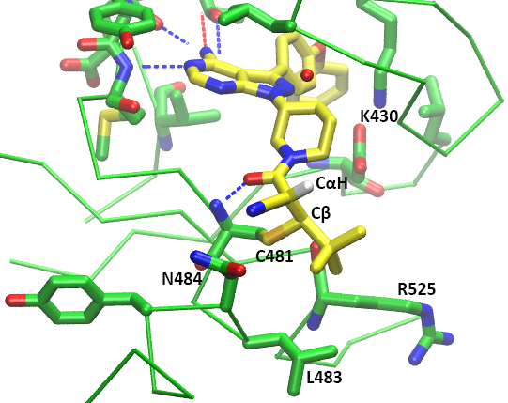

**Figure 4.** Co-crystal structure of BTK bound to the reversible covalent inhibitor **3** containing a cyanoacrylamide (2.2-Å resolution).4 The covalent bond between Cβ and Cys481, the acidic CαH hydrogen, and the hydrogen bonds that possibly contribute to stabilising the covalent adduct are indicated.

### 2.1.5 Previous Computational Studies of BTK.

Numerous computational studies have been performed on BTK, in many cases using molecular dynamics (MD) simulations. For instance, a combination of MD simulations and 3D quantitative structure-activity relationship (QSAR) models allowed highly efficient screening of noncovalent BTK inhibitors based on binding affinities.71-75 Related MD studies have helped to improve the understanding of the biological functions of different domains of BTK,76,77 the features involved in BTK changing from an inactive to an active state,78 and the interactions of BTK with its natural substrates, phosphatidylinositols.77,79 To date, only a single study associated with BTK has utilised QM calculations.71 That work employed density functional theory (DFT) to calculate the electronic excitation energy of BTK-targeting inhibitors. The functional and basis set combination chosen for the geometry optimisations of the detected hits was the B3LYP/6-31G*, which is notorious for its poor treatment of London dispersion.80,81 Fortunately, this suboptimal choice was somewhat attenuated by the fact that the study only focused on the structures of the inhibitors and not their thiol adducts, thus avoiding problems associated with spurious charge-transfer complexes. The limitations of the standard DFT methods in the modelling of thiol additions will be discussed further in the following methodology section. Taken together, however, the body of computational work reported thus far illustrates the many possibilities for gaining atomistic insight into BTK inhibition using appropriate computational tools.

## Objectives

The ultimate goal of the present work is to elucidate the factors that affect the kinetics and thermodynamics of thiol additions in the context of the binding of cyanoacrylamide-containing Michael acceptors to Cys481 of BTK. The intention is to perform the first ever study of BTK binding site environmental effects on the reactivities of these inhibitor molecules. It is hoped that a deeper understanding of the binding interactions will enable more rational design of BTK inhibitors in the future. Such an understanding would also facilitate the design of reversible covalent inhibitors for other kinases.

In this project, these goals were approached in the following way:

first performing QM calculations to determine the intrinsic reactivities of different cyanoacrylamide warheads towards a model thiol, followed by MD studies to explore the impact of residues near BTK binding site on the reactivities of the inhibitors.

the results of these computationsare anticipated to

# QUANTUM CHEMICAL CHARACTERISATION OF THE INTRINSIC REACTIVITIES OF COVALENT INHIBITORS.

## Methods

From Taunton’s set of inhibitors , six examples were selected for detailed study to reveal how structural factors determine the intrinsic reactivities of acrylamide warheads (GRAPHIC). First, acrylamide **3** was chosen due to the availability of its co-crystal structure with BTK. The related acrylamide **1**, with a methyl group in place of the *tert*-butyl of **3**,was chosen to compare with **3**. The pair of enantiomers **4** and **7** were next chosen, to explore the effect of the different configurations of the stereogenic centre in the linker. Inhibitor **9** was chosen as it displayed the longest RT out of those studied by Taunton. Finally, the acrylamide **5**, lacking a cyano group, was included as a control, as it exhibited irreversible BTK inhibition. As the computational expenses grow exponentially with increasing number of atoms, the scaffolds of the inhibitors were truncated to XYZ groups. Their effects on the intrinsic reactivity are likely to be minimal, due to their remoteness from the electrophilic centre. The truncated inhibitors will be differentiated from the original molecule by adding the prefix **R** to the compound number, e.g. **R3** is the model for **3**. As a special case, the truncated forms of **4** and **7** are identical and are labelled **R47**.

### Factors Influencing Choice of QM Methods

Historically, the first computational studies of thiol-Michael additions were performed using *ab initio* methods by Kollman et al.84 Subsequently, several related studies85-87 have been conducted using DFT methods instead due to their more favourable computational cost-to-accuracy ratio.88 A critical observation was made by Smith et al.80 who noted that several popular DFT functionals give spurious results for thiol-Michael additions, due to delocalisation errors, where the inconsistent correction of the self-repulsion in the dominant Coulomb functional leads to an artificial spreading of the electron density.89 In fact, artefactual charge-transfer complexes stabilised by this excessively delocalised electron density had led other researchers unaware of the problem to propose alternative mechanisms for thiol addition, including a concerted water-mediated addition90 and a direct 1,2-addition.91 Proper selection of a QM method is therefore critical to gaining reliable insights into the intrinsic properties of thiol-Michael reactions. It is important that only QM methods that are known to perform reliably for thiol Michael additions be used and special attention ought to be given to the mitigation of the delocalisation errors. The development of range-separated functionals,92-95 which incorporate a greater proportion of Hartree-Fock (HF) exchange at long-range while maintaining the typical generalised gradient approximation (GGA) functional at short distance, have proven to be effective in correcting the aforesaid error and have therefore been used in this project.80

### Properties of Interest

The application of statistical mechanics to QM systems allows the derivation of thermodynamic quantities including Gibbs free energy, $G$, from the partition functions.96 The activation free energy barrier ($ΔG^{‡}$) and free energy change ($ΔG$) for the addition of a thiol to a Michael acceptor (or the reverse reaction, elimination) can therefore be estimated from QM calculations on reactants, TS and products. The rate constant for thiol elimination (off-rate), $k_{off}$, can be computed using equation (2), the Eyring equation:97

|  |  |  |
| --- | --- | --- |
|  |  | (2) |

where $T$ is absolute temperature, $ΔG_{reverse}^{‡}$ is the elimination activation barrier calculated by DFT, $k_{B}$, $h$ and $R$ are Boltzmann’s constant, Planck’s constant and gas constant, respectively, and $κ$ is a transmission coefficient, which reflects the fraction of the molecules overcoming the activation barrier that proceeds to the product without recrossing the TS. Assuming that the no-recrossing assumption of the TS theory97 is held, a value of 1 is typically assigned to $κ$. The calculated results can be compared with the experimentally measured half-life, $t_{1/2}$, which is related to $k_{off}$ by a factor of $ln⁡(2)$ for first order reactions as shown in equation (3):

|  |  |  |
| --- | --- | --- |
| $$t_{1/2}=τln⁡(2)$$ |  | (3) |

The $ΔG$, $ΔG^{‡}$, $k_{off}$ and $t_{1/2}$ values were calculated for thiol additions to Taunton’s cyanoacrylamide warheads (Chart 1). To minimise the computation required for the expensive QM calculations, the relatively unimportant structural features of the inhibitors to the study of the warhead reactivities such as the kinase recognition scaffold were truncated.

### Conformational Sampling

The reactivity of a molecule is highly dependent on its geometry. Since molecules at any temperature constantly undergo changes in their molecular geometries, e.g. through vibrations, measured properties are an average over the ensemble of all possible states. The properties are predominantly determined by the lowest energy conformers as the conformational population follows a Boltzmann distribution as shown in equation (4):

|  |  |  |
| --- | --- | --- |
| $$\frac{N_{i}}{N_{total}}=\frac{e^{-E_{i}/RT}}{\sum_{k=1}^{M}{e^{-E_{k}/RT}}}$$ |  | (4) |

where $N_{i}$ is the expected number of particles in the single-particle microstate $i$, $N_{total}$ is the total number of particles in the system, $E_{i}$ is the energy of microstate $i$, $R$ is gas constant, $T$ is the equilibrium temperature of the system, and $M$ is the total number of microstates. As such, the most important conformers for the key species involved in a reaction, namely reactants, TS structures and products, need to be identified prior to the calculation of the thermodynamic parameters.

The conformational searching essential to the identification of the ground state conformers was guided by molecular mechanics (MM) to enable efficient exploration of the large conformational space. This was done for each species using mixed torsional/low-mode sampling (MTLMS) method in the MacroModel software,98 which has been demonstrated to be a superior sampling method for flexible compounds.99 The algorithm applies Monte-Carlo sampling to the torsional degrees of freedom while the energy minima are searched for along the directions of the low-frequency vibrational mode eigenvectors. For thiol adducts, all possible diastereomers were constructed and the lowest-energy diastereomer was used for analysis. For TSs, *syn* (C-S--C=C dihedral angle < 90º) and *anti* (C-S--C=C dihedral angle > 90º) conformations for thiolate attack on both *Re* and *Si* faces of the Michael acceptor were calculated. In the cases where the orientation of the conformers returned from the conformational sampling was reversed, manual adjustment was applied to give the desired orientation.

The molecular interactions were described using the OPLS3e force field.100 This force field is the current state of the art in MacroModel due to its more extensive parameterisation and reduced parameter transferability errors. Benchmarking was conducted and is discussed in the Appendix. The partial atomic charges were assigned based on the force field and an extended cutoff for non-bonded interactions was used. This corresponds to cutoff distances of 8.0 Å, 20.0 Å, and 4.0 Å, for van der Waals (vdW), electrostatic and hydrogen bonds respectively. The first 15 conformers with a mean absolute deviation (MAD) of at least 0.5 Å from previously located energy minima within an energy window of 3 kcal/mol were stored from a sampling of 1000 maximum steps and 100 steps per rotatable bond. The probability of a torsion rotation or molecule translation, minimum and maximum distance for low-mode move were set to be 0.5, 3.0, and 6.0, respectively. The implicit Generalised Born model augmented with the hydrophobic solvent accessible surface area (GBSA) was employed to simulate infinitely diluted aqueous solution. The S-C bonds to be formed in TSs were constrained during the samplings. The parameters chosen were mostly the default values of MacroModel conformational sampling job configuration, except for the range of the energy window.

### Calculation of Gibbs Free Energy

After conformational sampling, low-energy structures were then QM optimised and finally ranked according to their QM energies. The initial QM geometry optimisation is especially important for TSs to approximate the length of the S-C bonds prior to the searching of conformers. The thermodynamic parameter of interest, $G$, could be obtained from equation (5):

|  |  |  |
| --- | --- | --- |
| $$G=H-TS$$ |  | (5) |

where $T$ and $S$ are absolute temperature and entropy, respectively, while $H$ is enthalpy, which is computed from the addition of pressure-volume work, $pV$ to the internal thermal energy, $E$ as shown in equation (6):

|  |  |  |
| --- | --- | --- |
| $$H=E+pV$$ |  | (6) |

The geometry reoptimisation aimed to rank the energetic stability of the conformers to identify the most stable conformation. Due to the large number of conformers to be optimised, the geometry optimisations were performed using a single QM method known to be capable of capturing the essential components of thiol addition systems at reasonably low computing resource cost. In a previous benchmarking done on related thiol additions to acrylamides,43 the M06-2X/6-31+G(d) method had been found to yield rather accurate values of $G$. This method was therefore employed here for geometry optimisations. Once the most stable conformer for each species was identified at this level, $G$ values at a higher level of theory were then obtained by computing single-point values (at fixed geometries) and adding the thermochemical correction from the lower-level calculation, as shown in equation (7):

|  |  |  |
| --- | --- | --- |
| $$G_{HL}=G_{LL}+\left(E_{HL}-E_{LL}\right)$$ |  | (7) |

where $HL$ and $LL$ correspond to higher and lower levels of theory, respectively. the assumption being negligible change in $S$ over the course of reaction.

To choose a suitable combination of functional and basis set for the single point energy (SPE) calculations, a benchmarking study was carried out. A total of ten different methods was tested, as shown in Table 1. Previously, the methods SCS-MP2/6-31+G(d), B2PLYP-D/6-31+G(d) and M06-2X/6-311G(2d,p) hadperformed well in a solution phase study of thiol-Michael additions, as judged by comparison to high level ab initio CBS-QB3 calculations,101 while ωB97X-D/aug-cc-pVTZreturned high accuracy in a gas phase study of thiol addition in comparison to CCSD(T)/aug-cc-pVTZ//MP2/aug-cc-pVTZ calculations.80 M06-2X/6-311+G(d,p) was found to best describe the thermodynamic parameters in a solution phase study of thiol addition in comparison to experimental data.43 Combinations of these different functionals with a triple-zeta basis set, namely 6-311G(2d,p), were tested. It was expected that the performance of the DFT methods (M06-2X and ωB97X-D) would not necessarily scale with the size of the basis set, while the *ab initio* (SCS-MP2) calculations should increase in accuracy as a complete basis set is approached. The same is true for the double hybrid functional B2PLYP-D, which involves both a second-order perturbation correlation term (PT2) and HF exchange.

**Table 1. Combinations of functionals and basis sets chosen for benchmarking.**

|  |  |  |
| --- | --- | --- |
| Method | Functional | Basis set |
| **A** | B2PLYP-D | 6-311G(2d,p) |
| **B** | M06-2X | 6-311G(2d,p) |
| **C** | SCS-MP2 | 6-311G(2d,p) |
| **D** | ωB97X-D | 6-311G(2d,p) |
| **E** | ωB97X-D | aug-cc-pVTZ |
| **F** | ωB97X-D | 6-311G(d,p) |
| **G** | ωB97X-D | 6-311+G(d,p) |
| **H** | B2PLYP-D | 6-31+G(d) |
| **I** | M06-2X | 6-311+G(d,p) |
| **J** | M06-2X | 6-311G(d,p) |

The Gaussian 16102 software was used to carry out all DFT calculations. The ultrafine integration grids was used. Harmonic vibrational frequency calculations indicated whether stationary points were local minima or first-order saddle points and also provided unscaled zero-point energy and thermal corrections. $G$ values are reported below at a standard state of 1 mol/L and 25 ºC. The molecular orbitals computed in Gaussian 16 were visualised using GaussView 6.103 Programming scripts were written to enable batch generation and submission of QM calculation jobs, efficient tabulation of data, and data visualisation. A description of the new codes written during the project is included in the Appendix.

### Noncovalent Interaction Analysis

Noncovalent interactions (NCIs) between and within the molecules were visualised using NCIplot,104 where promolecular densities are analysed to identify the strength and type of NCI. The types of interaction were distinguished based on the sign of the second eigenvalue of the electron-density Hessian matrix, while the strength was assessed based on the density. A colour scale of -3 to 3 was used to colour the constructed surfaces.

## Conformational Analysis

The most stable conformers of the reactants, TSs, intermediates, and products for the addition of MeSH to each model Michael acceptor are shown in Table 2. Some brief comments about the conformational trends and the reasons for these trends will be made in the following subsections.

**Table 2. Most Stable Conformations of the Key Species of the Michael Reactions.**

|  |  |  |  |  |
| --- | --- | --- | --- | --- |
| Inhibitor | Reactant | TS | Intermediate | Product |
| **1** |  |  |  |  |
| **3** |  |  |  |  |
| **47** |  |  |  |  |
| **5** |  |  |  |  |
| **9** |  |  |  |  |

### Reactants

Interestingly, the conformational sampling algorithms of MacroModel failed to locate an s-*cis* conformer for **R1** within an energy window of 5.0 kcal/mol. The s-*cis* conformer of this cyanoacrylamide was thus built manually. The optimised s-*cis* conformer was more stable than all other conformers found from the MM-guided sampling, revealing a shortcoming in the MacroModel software. This finding should serve as a warning against using standard chemistry programs as black boxes and encourage consistent inspections of generated data with chemical intuition. Such issue implies that data visualisation is likely one of the most important aspects currently in the field of computational chemistry due to its still early stage of methodology development. An investigation into the reasons behind the apparent failure of MacroModel to locate the global minima was conducted. A full discussion of this issue is included in the Appendix.

For **R1**, **R47**, and **R5**,the most stable conformers have s-*cis* geometries. For **R9**, the s-*trans* conformer was most stable. The most stable conformer for **R3** is neither s-*cis* nor s-*trans*, but has a C=C-C=O dihedral angle of 90º. To understand the conformational preferences, the NCIs present in the molecules were visualised using the NCIplot software (Figure 5). Attractive interactions between the $α$ substituent of the Michael acceptor and nearby protons on the nitrogen heterocycle stabilise the s-*cis* conformers. The $π$ electron cloud of the nitrile group in **R1** and **R47** allows C-H··· $π$ interactions105 to be formed while a weaker CH···HC interaction106 is found in **R5**. The non-planar optimum dihedral angle of 90º in **R3** is thought to minimise the destabilising clashes between the *tert*-butyl group and the carbonyl group or nitrogen heterocycle. Besides, such positioning of the methyl protons also allows C-H··· $π$ interactions to be formed with the carbonyl $π$ electron cloud. For **R9**, the greater stability of s-*trans* conformer compared to the s-*cis* was unexpected. It was found that the s-*cis* conformation indeed had a lower potential energy, but higher $H$ and $G$ values than the s-*trans.*



**Figure 5.** Visualisation of the NCI of the reactants. A blue-green-red scale was used to indicate the strength and type of the interactions, with blue signifying strong attractive interactions while red indicates strong nonbonded overlap.

### Transition State Structures

All of the most stable TS conformations had a *syn* geometry; that is, the S-Me bond of the thiolate is approximately aligned with the C=C bond of the Michael acceptor. An investigation into the NCI within the TS conformations revealed the existence of stabilising C-H··· $π$ interactions between the SMe group and the cross-conjugated $π$ system. It is interesting to note that cross-conjugation is present in all of the Michael acceptors investigated except **R5**. The C=O and C=C bonds are conjugated with two other $π$ electron clouds that do not delocalise into each other. One would expect the centre of such cross-conjugations to be more concentrated in electron density, which could very well has led to the observation of the relatively more stable *syn* conformations.



**Figure 6.** Visualisation of the NCI of the TS. A blue-green-red scale was used to indicate the strength and type of the interactions, with blue signifying strong attractive interactions while red indicates strong nonbonded overlap.

### Intermediates

The $α$ carbon of all intermediates species is *sp*2 hybridised as expected. An interesting observation is that one of the methyl protons of the methylthiolate groups is positioned to be relatively closer to the $α$ carbon, presumably to provide electrostatic stabilisation as the electron density is concentrated on the $α$ carbon particularly. The CH-C $α$ distances are found to be 2.7 Å for the intermediate species except for **I5** which is 0.1 Å further away.

### Covalent adducts

The most stable geometry of **P3** was compared with the conformation of **3** observed in the BTK co-crystal structure by calculating the root mean squared deviation (RMSD) of the core atoms. In the crystal structure, the A and B chains each contained a bound **3**, which superimpose upon each other with an RMSD of 0.093 Å. In comparison, the RMSDs between the bound **3** and the calculated structure of **P3** are much larger, 1.295 Å and 1.266 Å, respectively. An alignment of all structures is shown in Figure 7. The QM optimised thiol adduct was found to have opposite chirality to the experimental structures, and therefore a more relevant geometry was generated using the *Mirror Molecule* function in MacroModel for the comparison under the assumption of equivalency of the $G$ values of enantiomers. Surprisingly, the QM calculations of the $G$ of the crystal structure geometries revealed that the conformations are actually astonishingly higher in $G$ relative to the ground state geometry by 110.2 kcal/mol and 110.9 kcal/mol, respectively. Prior to rationalisation of the findings, it should be kept in mind that the crystal structure conformations were solved experimentally through X-ray diffractions, which suffers from the loss of dynamic information as an average structure was summarised from the ensemble of distinct structures. The extremely high $G$ of the crystal structure conformations could then be comprehended when one considers the possibility of obtaining an unrealistic overall conformation due to the averaging of relatively different geometries. Nevertheless, the difference of 2 orders of magnitude tells that the excluded interactions between the inhibitor and its surrounding are extremely stabilising, such that huge penalties for distortions from its most favourable geometry could be compensated for.

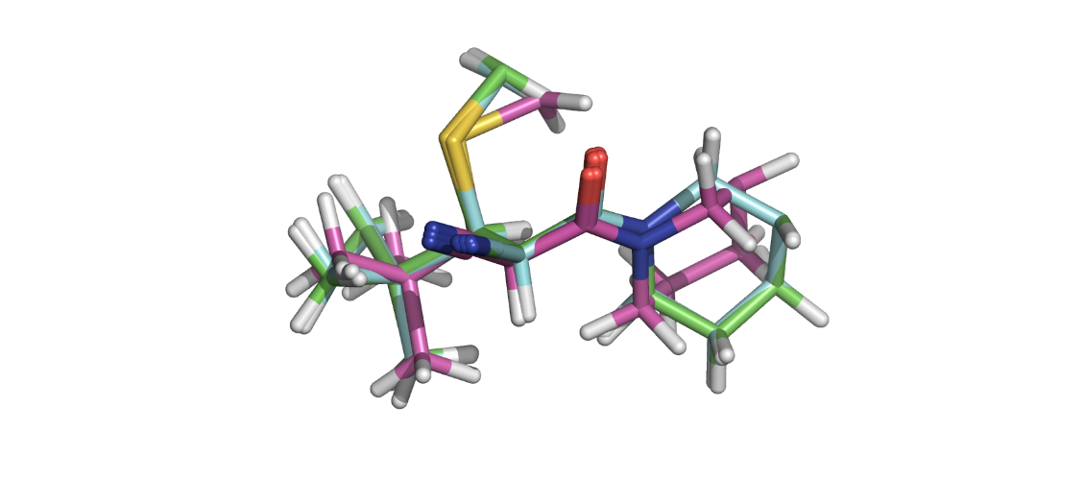

**Figure 7.** Superposition of calculated **P3** (pink) and the two conformations of **3** present in the co- crystal structure with BTK (A chain, green, and B chain, blue).

## Benchmarking of Functionals and Basis Sets for Thiol Additions

To begin, the values of $ΔG$ for a set of known thiol additions to cyanoacrylamides with experimentally available thermodynamics data were calculated in order to determine the best combinations of functionals and basis sets for calculating thiol addition reactions. The predictions of the addition $ΔG$ for entacapone (**15**)are collectively inaccurate, potentially due to the failure of taking the partial ionisation of the nitrocatechol group under the experimental conditions (PBS, 1-2% DMSO) into account.43 The uniform direction of the prediction error of the stability of the thiol adduct of **15** adds to the credibility of the hypothesis that the experimental results were obtained with negatively-charged nitrocatechol groups. **15** is thus excluded as an outlier for the statistical metrics to be recomputed.

The benchmarking results pointed toward Method I as the most accurate method in terms of prediction of the addition $ΔG$ for the cyanoacrylamides, while Method A performed the worst. Interestingly, Method A is the second most expensive method in terms of central processing unit (CPU) time. Methods C, G and I were able to predict the addition barrier to within 1 kcal/mol, considered “chemical accuracy”. The great performance of Method C validated the prediction that *ab initio* methods converge to the exact solution as the basis set tends toward full configuration interaction.

In contrast to the reduction of magnitude of error corresponding to complete basis set extrapolation, the usage of larger basis set for DFT methods such as Methods B, and D-F had been found to result in greater error on average. The relatively better performance of Methods G and I in this case should not be attributed to accurate description of the underlying physics of the system, but merely because the smaller basis sets resulted in some error cancellations that resulted in outcomes similar to the experimental data. That said, it is noteworthy that the inclusion of the diffuse functions for heavy atoms reduces the error of the DFT calculations by 0.2-0.5 kcal/mol, and therefore is encouraged to be included for future studies on similar systems if high accuracy is deemed to be more important than time expenditure.

Taken together, Method I was determined to be the method of choice for calculating thiol additions to cyanoacrylamides in this work.

**Table 3. Benchmarking calculations of ten different QM methods for the prediction of the deltaG values for addition of thiol (MeSH?) to Michael acceptors.**

|  |  |  |  |  |  |  |  |  |  |  |
| --- | --- | --- | --- | --- | --- | --- | --- | --- | --- | --- |
| Michael acceptor | Calc. $ΔG$ (kcal/mol) for Methods A–J | | | | | | | | | |
| A | B | C | D | E | F | G | H | I | J | |
| **10**  = -2.8*a* | 1.7 | -1.6 | -3.3 | -0.1 | 0.6 | -0.5 | -1.0 | -1.9 | -2.9 | -2.5 | |
| **11**  = -3.9*a* | 0.6 | -2.4 | -4.5 | -1.4 | -0.5 | -2.0 | -2.4 | -3.2 | -3.8 | -3.5 | |
| **12**  = -3.0*a* | 1.6 | -1.3 | -3.4 | -0.2 | 0.8 | -0.8 | -1.1 | -1.8 | -2.8 | -2.4 | |
| **13**  = -2.6*a* | 1.6 | -1.6 | -3.5 | -0.4 | 0.5 | -1.0 | -1.3 | -1.9 | -3.0 | -2.7 | |
| **14**  = -2.0*a* | 2.6 | -0.2 | -1.7 | 0.9 | 2.0 | 0.5 | 0.2 | -0.6 | -1.5 | -1.2 | |
| **15**  = -3.2*a* | -1.7 | -4.4 | -5.7 | -3.8 | -2.8 | -4.4 | -4.8 | -5.3 | -5.8 | -5.4 | |
| MAD | 4.0 | 1.4 | 0.8 | 2.3 | 3.0 | 1.9 | 1.7 | 1.3 | 0.7 | 0.7 | |
| RMSD | 4.1 | 1.4 | 1.1 | 2.4 | 3.3 | 2.0 | 1.7 | 1.2 | 1.1 | 1.0 | |
| Corrected*b* MAD | 4.5 | 1.5 | 0.5 | 2.6 | 3.6 | 2.1 | 1.7 | 1.0 | 0.3 | 0.4 | |
| Corrected*b* RMSD | 4.5 | 1.5 | 0.6 | 2.6 | 3.6 | 2.1 | 1.8 | 1.0 | 0.4 | 0.5 | |

*a*Experimental $ΔG$ values in kcal/mol. *b*Compound **15** was excluded for the computation of corrected metrics due to discrepancies in the modelled environment compared to the experimental conditions.

**Chart 2. Statistical Metrics from Benchmarking Results**.

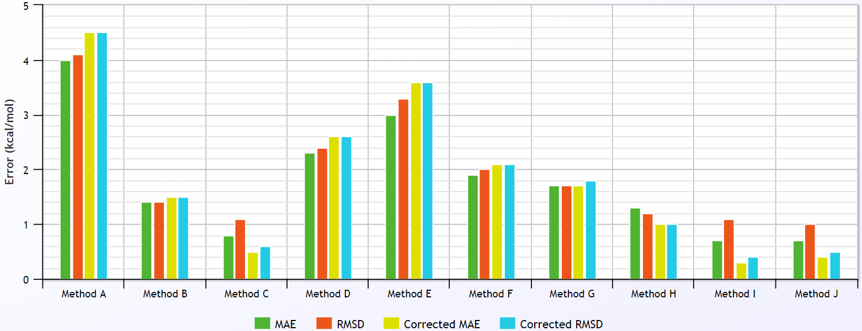

## Calculations of Thermodynamic Quantities

The $G$ values were obtained from $E$ values of the ground state species calculated using Method I. A comparison between the predicted $ΔG_{rev}^{‡}$ values and the experimental values is given in Table 4. The identity of the base catalyst in the BTK binding reactions is not known with certainty. Therefore, methylthiolate was used as a model base to compute the $ΔG_{rev}^{‡}$ values.

**Table 4. Comparison between calculated and experimental thermodynamic and kinetic parameters for thiol additions to Michael acceptors.**

|  |  |  |  |  |  |
| --- | --- | --- | --- | --- | --- |
| Michael acceptor | Expt. rank | Calc. *a* (kcal/mol) | Pred. rank*b* | Calc. $ΔG$ (kcal/mol) | Calc. $ΔG^{‡}$ (kcal/mol) |
| **R1 $ΔG_{rev}^{‡}$** = 22.8*c* | 5 | 11.8 | 4 | -4.0 | 7.8 |
| **R3 $ΔG_{rev}^{‡}$**  > 26.5*c* | 2*d* | 14.8 | 2 | -2.0 | 12.8 |
| **R47 $ΔG_{rev}^{‡}$**  = 25.1*c* | 4 | 11.2 | 5 | -2.1 | 9.0 |
| **R5 $ΔG_{rev}^{‡}$**  >> 26.5*c* | 1*d* | 25.8 | 1 | -9.0 | 16.8 |
| **R9 $ΔG_{rev}^{‡}$**  = 26.4*c* | 3 | 14.6 | 3 | -3.6 | 11.0 |

*a*Values calculated using methylthiolate as the base. *b*Ranked in descending order in terms of magnitude of . *c*Experimental $ΔG_{rev}^{‡}$ values in kcal/mol. *d*Despite the same magnitude of rounded $ΔG_{rev}^{‡}$, no recovery of **5** from its covalent adductwas observed experimentally over 200 hours, in contrast to the gradual recovery of **3**.

The in the calculatedsthe trend in the experimental.This is unexpected, to an extent, because the QM model systems do not include any of the of the BTK binding site.O do not have identical ranks in the calculations and experiments

The graphical representation in Chart 3 permits a closer examination of the relative magnitudes of the predicted and experimental $ΔG_{rev}^{‡}$ values. This plot reveals that although the calculations follow approximately the same overall trend as the experiments, the calculated reactivities for some of the Michael acceptors differ more from the experimentally-observed reactivities than do others. This indicates that the intrinsic reactivities of the warheads do not fully account for the observed experimental behaviour. The factors not captured in the QM model systems likely comprise a combination of stabilising or/destabilising effects that influence different adducts and TSs to different extents. These effects can only be determined through simulations of the full BTK–inhibitor systems which will give an indication of the binding site residues that contribute to these environmental effects.

**Chart 3. Comparison between Predicted and Experimental Elimination Barriers**

## Rationalisation of the Predicted Intrinsic Reactivities

In orderuncoverfactors that influence , analyses were performed to identify correlations between the predicted barriers and a range of electronic descriptors of the Michael acceptors. A statistical measure, $R^{2}$ value was computed from linear regression analysis of each of these properties. It should be stressed that the value simply indicates the extent to which the independent variable, which is the calculated $ΔG^{‡}$ in this case, is explained by the variation of a dependent variable in a regression model.107 Therefore, no conclusion regarding the quality and reliability of the underlying model, biasness of the data, nor choice of regression types could be made based on the values obtained.

### Lowest Unoccupied Molecular Orbital Energy

The calculated addition barriers were first compared to the lowest unoccupied molecular orbital (LUMO) energies of the reactants (Figure 8). Overall, a reasonably strong correlation was observed (*R*2 = 0.84). Inhibitors **R3**, **R47**,and **R5** fall close to the line of best fit, while the other two Michael acceptors, **R1** with the simplest warhead and **R9** with the most elaborate warhead, fall further from the linear relationship. This might indicate the presence of other factors in the determination of the intrinsic reactivities of the compounds.

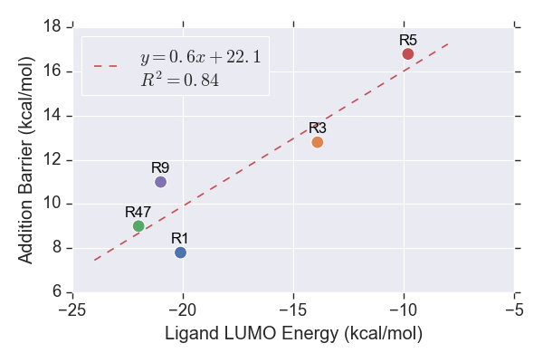

**Figure 8.** LUMO energies of the reactants.

### Earliness or Lateness of the Transition State

The distance between the sulfur atom of the methylthiolate and the electrophilic C $β$ of the Michael acceptor indicates the earliness or lateness of the TS along the reaction coordinate. This could serve as a measure of how advanced the bond-forming interaction between the reactant molecules must be for the addition to proceed. A longer S-C distance implies that the TS is achieved earlier in the reaction path. The calculated addition barriers are plotted against the S-C distance in Figure 9. A negative correlation (*R*2 = 0.88) is found. This indicates that the strength of the interaction between the reactants has a strong influence on the addition barrier.

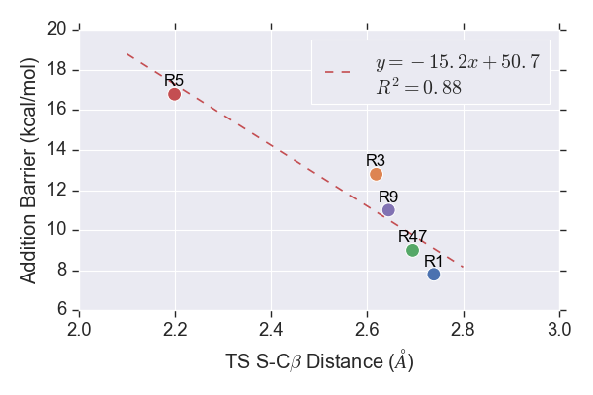

**Figure 9.** Distance between sulfur of methylthiolate and C $β$ of the Michael acceptors in the TSs.

### Charge on the $β$-Carbon

The next analysis of the addition barriers utilised concepts from conceptual DFT (CDFT) There has been a focus on discovering well-defined chemical concepts in order to allow qualitative understanding and quantitative prediction of chemical reactivity. The molecular responses during a reaction are thought to be dependent on the changes in the number of electrons and the external potential felt by the electrons. to calculate global descriptors that measure the overall susceptibility of a molecular system to electrophilic attack.

It is intuitive to expect an explicit relationship between the electron density distribution near the reacting site and the addition barrier. The speculation is in agreement with the concept of a global descriptor, namely electrophilicity index, $ω$, devised by Parr,108 defined in equation (4):

|  |  |  |
| --- | --- | --- |
| $$ω=\frac{χ^{2}}{2η}$$ |  | (4) |

where $χ$ and $η$ are electronegativity and chemical hardness, respectively. The electrophilicity $ω$ is defined as the extent of lowering of energy upon uptake of electron density. Electronegativity $χ$ is calculated from……(orbital energies?). Chemical hardness $η$ refers to the concentration of electron density around a particular atom in line with the Pearson hard-soft acid-base (HSAB) concept109 and is calculated from…….? The electrophilicity of an atom in a molecule is anticipated to be inversely proportional to its electron density.

The energies for the systems were modelled using the finite differences (FD) approach. The $ω$ values were computed based on Koopman’s theorem,[110](#_ENREF_110" \o "Koopmans, 1934 #337) where electron affinity (EA) and ionisation potential (IP) are simply approximated by the negatives of the LUMO and HOMO energies, respectively. However, care should be taken when the orbitals were chosen as the LUMO might not exhibit significant overlapping with the first HOMO in some cases, and hence is unlikely to participate in the electron donation to LUMO in the reaction. The orbitals were thus visualised in search for the most relevant HOMO. Further details regarding the process could be found in the Appendix. The relationship between the computed $ω$ values and the addition barriers is plotted in Figure 10.

An attempt was made to determine the extent of any correlation between the addition barriers and the partial atomic charge on the $β$-carbon of the Michael acceptor. Seven different charge calculation schemes were examined: …………..(name them) All of the charge schemes showed an inverse relationship with the addition barriers, as expected. In agreement with the notoriety of Mulliken population analysis regarding its unreliability as it allows unphysical negative electronic populations and blatantly violates Pauli Exclusion Principle,111 Mulliken charges exhibited the lowest $R^{2}$ value (0.22) followed by Merz-Kollman charges (0.39). All other charge schemes showed relatively good correlation (>0.69) with the charges computed from the quantum theory of atoms in molecules (QTAIM) returning the highest value (0.86). The addition barriers are described rather well by the $ω$ values ( $R^{2}$ = 0.73). An interesting observation is that an exponential-like relationship was observed for natural bond orbital (NBO), Hirshfeld and Charge Model 5 (CM5) charge schemes.

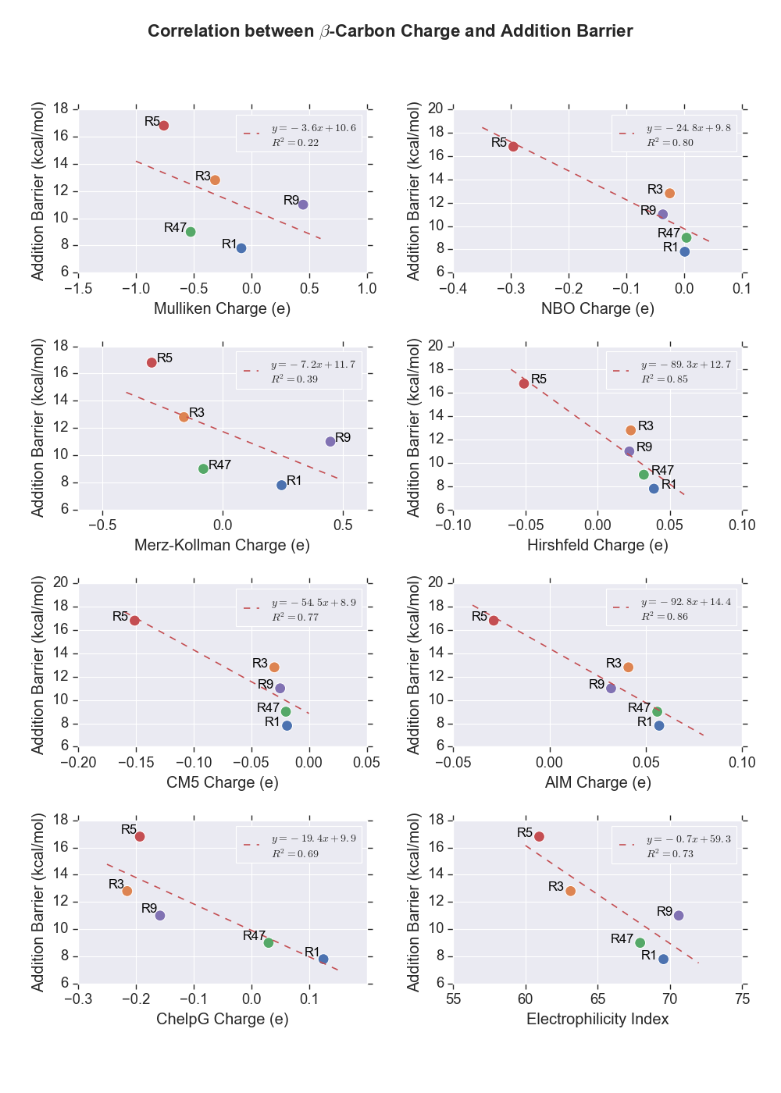

**Figure 10.** Partial charges of $β$-carbon and $ω$ of the Michael acceptors.

### Distortion/Interaction Analysis

The distortion/interaction model of reactivty112 was used to analyse the reactivity trend across the investigated cyanoacrylamide Michael acceptors. In this model, the activation energy for a reaction, $ΔE^{‡}$, is understood as the sum of (i) the energies required to distort the reactants into their TS geometries, $ΔE_{d}^{‡}$, and (ii) the interaction energy between the distorted reactants in the TS complex, $ΔE_{int}^{‡}$, as shown in equation (5):

|  |  |  |
| --- | --- | --- |
| $$ΔE^{‡}= ΔE_{d}^{‡}+ΔE_{int}^{‡}$$ |  | (5) |

Plots showing the correlations between the computed barriers and the distortion and interaction energies are shown in Figure 11.

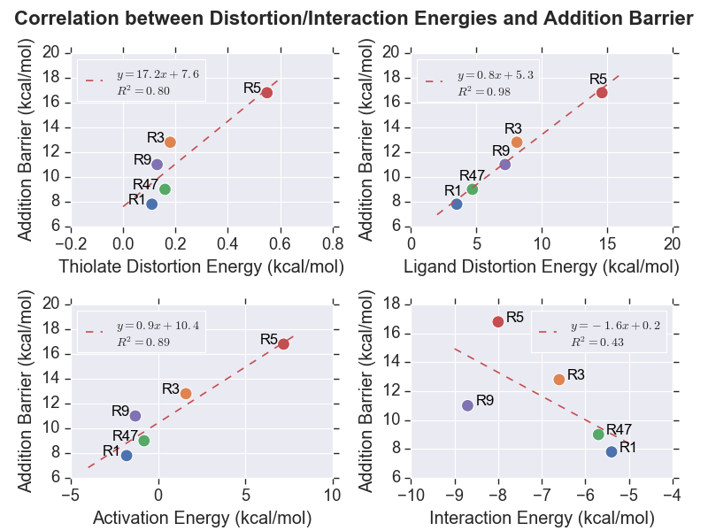

**Figure 11.** Plots showing the relationship between the computed addition barriers and (a) the thiolate distortion energies (upper left), (b) the acrylamide distortion energies, (upper right), (c) the free energies of activation (lower left) and (d) the interaction energies (lower right).

The amount of strain that the methylthiolate anion has to overcome to achieve the TS, $ΔE_{d_MeSH}^{‡}$ is small and varies little across the five acrylamides. One acrylamide, **R5**, differs from the other four and has undergone a greater distortion to reach the TS. The hypothesis was tested by comparing the similarities of the geometries of each methylthiolate in TS relative to its ground state structure. The results which are tabulated in Table 5 provides strong evidence to support the speculation. A more detailed investigation on the distortion of methylthiolate anion in **TS5** was discussed in the Appendix.

**Table 5.** RMSD of methylthiolates in TS for each inhibitor from the ground state structure.

|  |  |
| --- | --- |
| Transition State | RMSD (Å) |
| **TS1** | 0.0026 |
| **TS3** | 0.0042 |
| **TS47** | 0.0023 |
| **TS5** | 0.0082 |
| **TS9** | 0.0026 |

Despite the positive correlation observed ( $R^{2}$ = 0.80), the relative miniscule magnitudes of the $ΔE_{d_MeSH}^{‡}$ most probably did not influence the addition barriers in any significant way. In contrast, the distortion energies of the Michael acceptors, $ΔE_{d_MA}^{‡}$, which dominated the unfavourable components show a very strong correlation with the addition $ΔG^{‡}$ values, as evidenced by the $R^{2}$ value of 0.98.

The $ΔE^{‡}$ values also exhibited a rather strong correlation with the predicted values ( $R^{2}$ = 0.89). Interestingly, some of the reactions displayed negative $ΔE^{‡}$ values. This result was attributed to the formation of low-energy vdW complexes prior to formation of the TS. As illustrated in the energy profile in Figure 12, the negligence of the entropic effect, which could be up to 12 kcal/mol for organic small molecules, has resulted in lower potential energy of the TS relative to the infinitely separated and diluted reactants. That said, the strong positive correlation observed indicates that the effects of the $pV$ work done and the change in entropy, $ΔS$, on the addition barriers of the inhibitors investigated are uniform enough such that the trend of $ΔE^{‡}$, which omits these terms, is approximately the same as the trend of $ΔG^{‡}$.

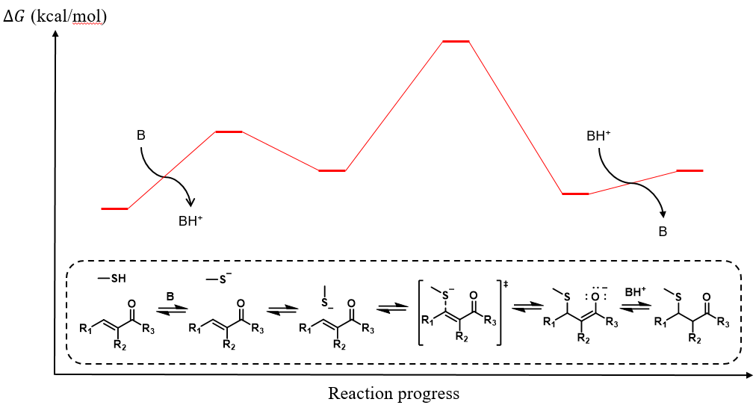

**Figure 12.** Illustrative potential energy profile.

A rather low $R^{2}$ value of 0.43 was returned from the linear regression analysis on the interaction energies. A closer look at the data suggests that **R9** is highly likely an outlier as a better linear fit could be obtained with the data point excluded. For further analysis, the interaction energy could be further dissected into individual components, including electrostatic, polarisation, exchange repulsion, and charge transfer interactions.113 The independent investigations on each aspect of these noncovalent interactions might allow pinpointing of the component that contributed most significantly to thiol-Michael additions.

The investigations above have demonstrated that the intrinsic addition barriers for the thiol-Michael additions do correlate with certain molecular properties, with the ligand distortion energy being the most prominent one. However, it should be recalled that correlation does not imply causation, and therefore further experimentations and statistical research would be required to explore the cause-and-effect relationship between the highlighted parameters.

# INCORPORATION OF THE ENVIRONMENTAL EFFECTS

## Methods

All production MD simulations were conducted using AMBER18 *pmemd.cuda* program114-116 installed on a Dell EMC-manufactured high-performance computer named Wiener, which is hosted at the University of Queensland. The preparation of the systems and energy minimisations were carried out using a series of programs of GROMOS++ version 1.4.0.117 Twenty-four systems in total (covalently bound BTK with and without thiol adduct deprotonation, noncovalently bound BTK with and without cysteine thiol deprotonation) were considered for the study.

### Structure Preparation

All protein topology parameters were obtained from GROMOS11 54A7 force field118 in the form of interaction function parameter (ifp) and molecular topology building block (mtb) files from the Automated Topology Builder (ATB) version 3.0 web server.119,120 ATB was also used to generate the topology parameters of ligands **1**, **3**, **4**, **5**, **7**, and **9** in the form of unreacted compound and covalently bonded form with a cysteine residue. The geometry was optimised at the B3LYP/6-31G* level of theory in water using polarizable continuum model (PCM). The electrostatic potential (ESP) was then calculated using the optimised geometry, from which the charges were obtained from least-squares fitting. The details of the parameter assignment protocol was described in their first paper.119

The simulated systems were built based on the X-ray crystal structure of a BTK dimer inhibited by 2 inhibitors **3** (4YHF)made publicly available on the Protein Data Bank (PDB) by Taunton’s group. The missing residues at the ends of both residue chains A and B were built in as a linear chain using PyMOL.121 The N terminals were left as NH3+ while C terminals were left as COO-. Swiss PDB Viewer was employed to add the missing atoms through reconstruction of the side chains.122 Molecules other than BTK and **3** such as SO42- anions and ethylene glycol were present due to the buffers added during protein crystallisation. They were thus purged from the PDB file. Modification of the covalently bonded inhibitors **3** to the reactant state was done by removing the extra proton acquired from thiol addition and adjusting the orbital hybridisation. was used to generate the topology files. The topology files of the residue chain A, chain B, and **3** were generated separately using the *make_top* program and then combined using the *com_top* program. The protonation state of the each residue was decided based on the predicted $pK_{a}$ values made by PROPKA version 3.1.123,124 A residue is protonated if its $pK_{a}$ value is equal to or lower than the physiological pH value, which is 7.4. The residue and atom names of **3** in the PDB file were then updated to match the mtb file obtained from the ATB. The *pdb2g96* program was used to generate a coordinate file of the system in GROMOS96 format followed by the positional adjustment of the hydrogen atoms by the *gch* program.

The protein and ligands were first energy minimised in vacuum over 5000 steps using steepest descend method with a tolerance of 0.01 kJ/mol before solvation in a rectangular box of simple point-charge (SPC) water with a minimum distance of 14 Å between the protein and the wall using the *sim_box* program. For the systems involving deprotonated species, the overall charges of the periodic systems are negative overall. The neutralisation was achieved by replacing the water molecule with the highest potentials with sodium ions. The solvated system was then energy minimised again over 5000 steps. The strained bonds, angles, improper dihedrals, and dihedral angles were identified from the *check_top­* program. A positional restrained energy minimisation was then carried out by first applying a harmonic potential to the coordinates of the protein structure in place, with the unfavourable degrees of freedom excluded. The details of the unmentioned parameters were included in the Appendix.

The GROMOS system topologies (.top) and coordinates (.cnf) were converted into AMBER-compatible format (.prmtop and .mdcrd, respectively) utilising the topology converter on the ATB web server. The residue name for water solvent was specified to be H2O to enable the application of the SETTLE constraint algorithm.125

### Simulation Setup

The systems were first equilibrated as a canonical (NVT) ensemble for 100 ps. The velocities of the atoms were initialised based on the sampling from Boltzmann distribution at 298.15 K. The systems were then heated up to 310.15 K and maintained constant with a Berendsen thermostat.126 A 2 ns isobaric-isothermal (NPT) equilibration with a pressure of 1 atm maintained using Berendsen barostat[126](#_ENREF_126" \o "Berendsen, 1984 #66) was then carried out to adjust the box density followed by another 12 ns NVT equilibration.

All-atom NVT simulations was carried out for 100 ns for each system. Berendsen algorithm was applied to maintain simulation temperature of 310.15 K and pressure of 1 atm with coupling time constants of 0.1 and 0.5 respectively. The isothermal compressibility of the system was set to 45.75×10-6 bar-1. The time constants were chosen such that the resonance between the temperature-pressure couplings could be avoided. Periodic boundary conditions (PBC) were imposed to avoid edge effects. Long-range Coulomb interactions were handled using the particle mesh Ewald (PME) method.127 The SHAKE algorithm128 with tolerance of 10-5 was utilized to constrain the bond involving hydrogen atoms. Despite this, a time step of 1 fs was used due to the relatively high temperature of simulation. Both the Coulomb and the vdW interactions were truncated at 1.4 nm. A dielectric constant of 1.0 was used. The coordinate trajectories were recorded every 1 ps. The SETTLE algorithm was employed to constrain the geometry of water molecules for higher throughput.

### Trajectory Analysis

The results were analysed using the CPPTRAJ program129 and plotted using Python scripts written as appended. The systems were visualised using visual molecular dynamics (VMD)130 analysis toolkit.

## Identification of Potential Base Species

### Distance from Charged Residues

Distance analyses are carried out in attempt to search for potential base species. There is a convention in the field that assumes that the basic residues are unable to act as basic catalysts as they are often protonated at physiological pH.[131](#_ENREF_131" \o "Gerlt, 1991 #339) However, there has been growing discoveries on the role of basic residues as biological basic catalysts lately.132,133 Taking these into considerations, all charged residues, including histidines, lysines, arginines, glutamates, and aspartates are nominated as likely candidates of the participating base in the thiol addition/elimination. Considering that it took more than 200 hours for **3** to dissociate from BTK experimentally, a relatively significant change in the conformation is likely needed prior to the extraction of C $α$ proton and further advancement of the reverse reaction.

The moments when the charged residues approached the C $α$ proton to within 10 Å are captured by the 100 ns MD simulations of **1** and **3** covalently bound to BTK. The closest distances sampled for both systems are about 5 Å (Arg384 and Arg422), which is still relatively far from the expected geometry of the TS. That said, some arginines and glutamates have certainly demonstrated greater flexibility to approach the targeted proton and thus are regarded as the most likely candidates of base catalyst for the thiol eliminations. On the other hand, the distance of the charged residues from the thiol protons of Cys481 in the simulations of noncovalently bound BTK has allowed the identification of promising candidate for the base catalyst in the forward reaction. The carbon atom of the guanidine group of Arg424 and Arg146 went to as close as 2 Å from the thiol proton at one point in the simulations, giving rise to the prospect of arginines being the base that deprotonates Cys481 to allow the advancement of the thiol additions. The relevant data plotted in figures could be found in the Appendix.

### Transition States for C $α$ Proton Abstractions

Assuming that an arginine is acting as the base in the deprotonation of the thiol adducts, the TS structures were located and the energy barriers for the deprotonation step were computed. An investigation into the possibility of thiol eliminations through 6-membered and 4-membered intramolecular proton transfer was also conducted for comparison. Figure 13 shows the energy profiles for the intramolecular thiol eliminations in comparison with the conventional base catalysed elimination mechanism for **R1** and **R3**. The much higher energy barriers of the intramolecular reactions indicated that the reaction paths are much less likely to be taken.



**Figure 13.** Illustrative energy profiles of intramolecular and base catalysed thiol eliminations.

## Construction of Energy Profile

Putting together the information, the complete energy profiles of thiol-Michael additions to the truncated Michael acceptors are constructed as shown in Figure 14.

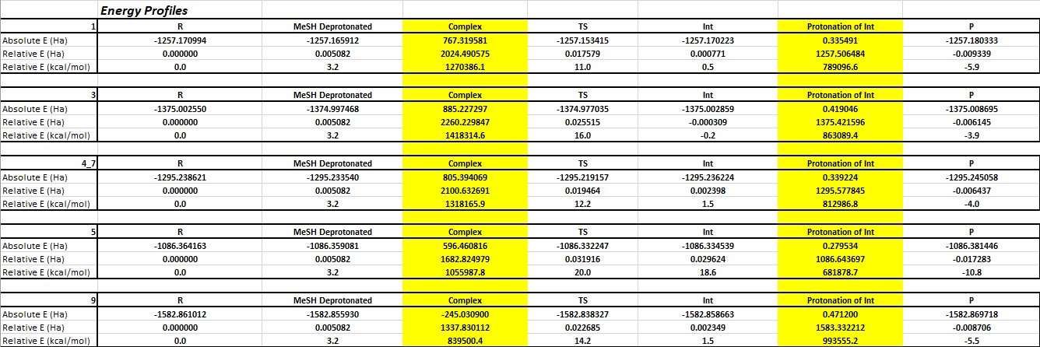

**Figure 14.** Complete energy profiles of thiol-Michael additions of methylthiols to **R1** (upper) and **R3** (lower).

The comparison of the energy profiles.

## Conformational Distribution

### Molecular Strains of Inhibitors

An unsupervised machine learning algorithm known as k-means clustering was used to identify 15 clusters from the simulations of each noncovalently and covalently bound BTK systems containing **1** and **3** based on their coordinates RMSD. The single point energy of each geometry is calculated using OPLS3e force field using the *Current Energy* function in MacroModel and a Boltzmann averaged energy was calculated. This is then compared to the average energy from the Boltzmann analysis of the first 15 conformers obtained from the conformational sampling using the same force field. It should be noted that the inhibitors are parameterised using GROMOS force field and thus the geometries of the inhibitors sampled from the MD simulations might not be ideal according to OPLS3e force field. Assuming perfect transferability of the force field parameters, the difference in the Boltzmann averaged energy of the geometries from MD simulations and the most stable conformers sampled by MacroModel would indicate the amount of strain exerted by the environmental residues on the inhibitors.

**Figure 15.** Superposition of the conformers from k-means clustering of MD simulation trajectories (left) and MacroModel conformational sampling (right).

### Localised Strains of Warheads

The same protocol was applied to the warhead portions of the inhibitors to investigate the contributions of the strains in the reactive parts to the overall strain.

**Figure 16.** Superposition of the conformers from k-means clustering of MD simulation trajectories (left) and MacroModel conformational sampling (right).

## Interactions between Cyanoacrylamides Inhibitors and BTK Active Site Residues

### Distance of Cys481 Sulfur Atom from Electrophilic Carbon on Ligands

The distances between the atoms participating in the Michael addition throughout the simulations are presented as distribution plots. Learning from the QM calculation of the TS of the Michael addition, it is expected that the reaction happens when the S-C distance is about 2.7 Å, 2.6 Å, 2.7 Å, 2.2 Å, 2.7 Å and 2.6 Å respectively for the Michael acceptors in numerical order. None of the simulations managed to sample a frame where the distance is close enough for the TS to be achieved. It is interesting to note that the distance was maintained at about 3.8 Å throughout the 2 simulation replicates for **3**. Visualisation of the trajectories revealed that .

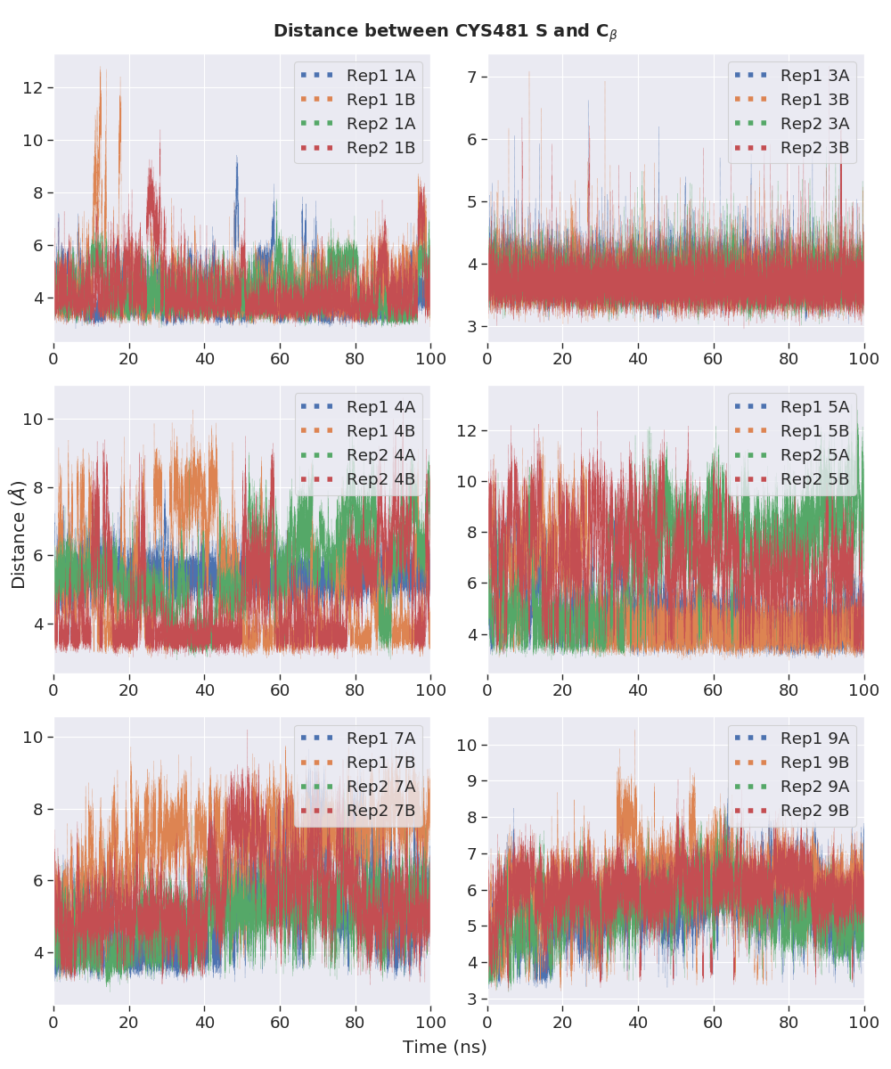

**Figure 12.** Distance between the $β$-C of the inhibitors and the sulfur atom of the Cys481 thiolate anions.

### Dihedral Rotations about C=C-C=O Bonds

The distributions of the rotations of the bond connecting carbonyl C and the $α$-C for all noncovalently bound inhibitors are plotted as shown in Figure 13. It is seen that for **1** and **3**, the 2 planes are maintained at about 100°. It is interesting to note that the mode of the distributions of chain A ligands for **4**, **7**, and **9** have opposite signs.

For **5**, while the angle favoured negative values, the distributions are skewed to the right, indicating that the barrier for the dihedral rotation is relatively lower. Inhibitor **5** could thus be logically predicted to undergo relatively faster thiol addition due to the greater flexibility to rotate around the dihedral and hence has a higher chance to achieve the TS.

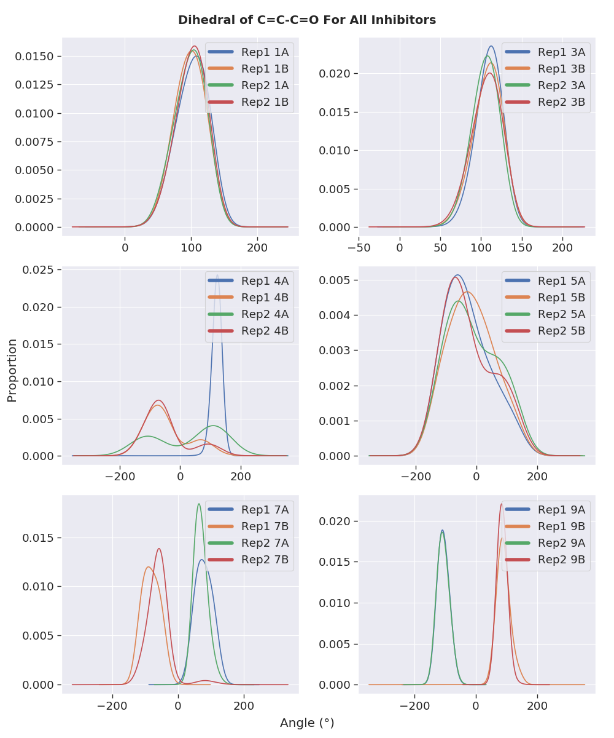

**Figure 13.** Distributions of the C=C-C=O dihedral angles throughout the 100 ns MD simulations of noncovalently bound BTK inhibitors.

# FUTURE DIRECTION – DETAILED INVESTIGATION OF THE EFFECT OF BINDING SITE RESIDUES ON THE REACTIVITY.

## Concept of QM/MM

Despite their usefulness in describing chemical reactions, pure QM calculations are restricted to systems containing up to a few hundred atoms. The modelling of biomolecular systems where reactions occur within a protein environment often requires inclusion of thousands of atoms. This necessitates different computational techniques such as hybrid QM/MM methods for practicality purposes. As illustrated in Figure 10, the basic principle of these methods is to treat the chemically active region at QM level whereas the interactions within the protein surroundings or the explicit solvent molecules are represented using MM potential functions, commonly known as force fields, which allow reduced computation through simplification of the underlying physics.

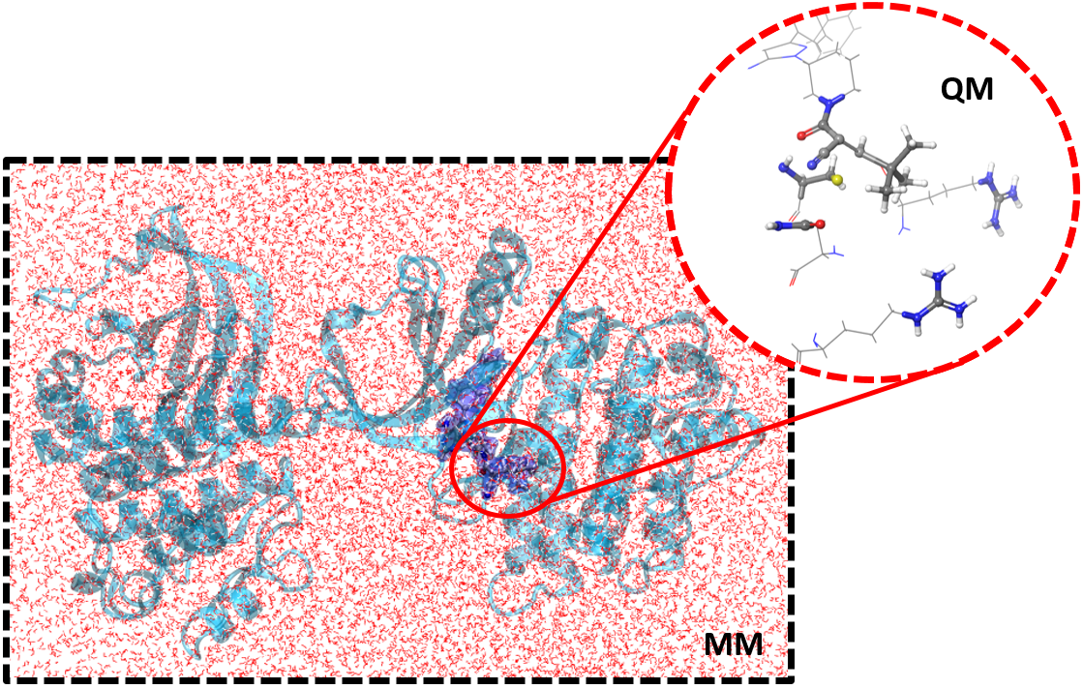

**Figure 10.** Illustration of the QM/MM concept.

Such an approach allows the electrostatic and steric effects of the protein on the reaction to be accounted for while ensuring accurate representation of the electronic structure in the vicinity of the reacting atoms. The multiple strengths of these hybrid methods are that the simulation cost and accuracy with the entire system included explicitly in the calculations are balanced and that they complement experimental data, allowing different mechanistic proposals to be supported or contradicted.

Ever since the pioneering study conducted by Warshel and Levitt on the mechanism of the lysozyme reaction, QM/MM methods have received extensive use in recent years as a versatile tool for the study of enzymatic reaction mechanisms,134-140 calculation of spectroscopic properties,141,142 prediction of p*K*a values143 and investigation of electronically excited states.144 The value of QM/MM methods in the field of computational enzymology can be appreciated from the multiple mechanistic studies conducted on a diverse range of kinases, including the more recent reports on isopentenyl phosphate kinase,137 mevalonate kinase,136 and *N*-acetyl-L-glutamate kinase,135 just to name a few. As such, it is anticipated that a similar study on BTK would provide insightful details about the inhibition mechanism of BTK of use to future research.

## Location of TS Structures

A QM/MM system could be built for each inhibitor based on a snapshot of the MD simulations of the covalently and noncovalently bound BTK for more detailed studies on the thiol eliminations and additions, respectively. The frame should be selected such that the positions of the reactive moieties are close to the TS geometries. This would allow for calculations of reaction profiles for the Michael reactions. Some potential investigations that could be conducted include the verification of the participating base, the illumination of the roles of specific residues near the binding site, and the location of TS structures. Once the TS structures of the Cys481 thiol additions/eliminations to the inhibitors areidentified, the comparisons with the geometries throughout the MD simulations would indicate the closeness of the geometries to the TS. The variations in reaction for different warheads could also be examined through structural modification of the warheads. The calculated kinetic parameters could be compared to the experimentally measured RT of the inhibitors to extent of inclusion of the environmental factors.

## Selectivity of Inhibitor for BTK

The experimentally observed selectivity of **9** for BTK over other kinases could potentially be studied following the examination of the binding site effects. Employing the same techniques, QM/MM studies of the binding of **9** to other kinases such as EGFR, ITK and TXK could be constructed readily from the widely available X-ray crystal structures of the unbound proteins. The bound forms could be prepared by selecting a snapshot from the MD simulations of the kinases with a selected inhibitor in proximity for QM/MM analysis. The structural features responsible for the apparent kinase selectivity of the inhibitorcould then be uncovered from a comparison among the kinases. The approach developed in the study of the selectivity of **9** would serve as the foundation for future studies of the selectivities of other inhibitors, providing a broader evaluation of the factors that influence selectivity.

# CONCLUSION

# REFERENCES

1. Potashman, M. H.; Duggan, M. E. *Journal of Medicinal Chemistry* **2009,** *52*, 1231-1246.

2. Smith, A. J. T.; Zhang, X.; Leach, A. G.; Houk, K. N. *Journal of Medicinal Chemistry* **2009,** *52*, 225-233.

3. Singh, J.; Petter, R. C.; Baillie, T. A.; Whitty, A. *Nature Reviews Drug Discovery* **2011,** *10*, 307-317.

4. Bradshaw, J. M.; McFarland, J. M.; Paavilainen, V. O.; Bisconte, A.; Tam, D.; Phan, V. T.; Romanov, S.; Finkle, D.; Shu, J.; Patel, V.; Ton, T.; Li, X.; Loughhead, D. G.; Nunn, P. A.; Karr, D. E.; Gerritsen, M. E.; Funk, J. O.; Owens, T. D.; Verner, E.; Brameld, K. A.; Hill, R. J.; Goldstein, D. M.; Taunton, J. *Nature Chemical Biology* **2015,** *11*, 525-531.

5. Serafimova, I. M.; Pufall, M. A.; Krishnan, S.; Duda, K.; Cohen, M. S.; Maglathlin, R. L.; McFarland, J. M.; Miller, R. M.; Frödin, M.; Taunton, J. *Nature Chemical Biology* **2012,** *8*, 471-476.

6. Tóth, L.; Muszbek, L.; Komáromi, I. *Journal of Molecular Graphics and Modelling* **2013,** *40*, 99-109.

7. Wright, P. M.; Seiple, I. B.; Myers, A. G. *Angewandte Chemie International Edition* **2014,** *53*, 8840-8869.

8. Kahan, F. M.; Kahan, J. S.; Cassidy, P. J.; Kropp, H. *Ann N Y Acad Sci* **1974,** *235*, 364-386.

9. Uetrecht, J. *Chemical Research in Toxicology* **2008,** *21*, 84-92.

10. Uetrecht, J. *Chemical Research in Toxicology* **2009,** *22*, 24-34.

11. Chen, M.; Suzuki, A.; Borlak, J.; Andrade, R. J.; Lucena, M. I. *Journal of Hepatology* **2015,** *63*, 503-514.

12. Yuan, L.; Kaplowitz, N. *Clinics in Liver Disease* **2013,** *17*, 507-518.

13. Mintzer, D. M.; Billet, S. N.; Chmielewski, L. *Advances in Hematology* **2009,** *2009*, 1-11.

14. Barf, T.; Kaptein, A. *Journal of Medicinal Chemistry* **2012,** *55*, 6243-6262.

15. Mah, R.; Thomas, J. R.; Shafer, C. M. *Bioorganic & Medicinal Chemistry Letters* **2014,** *24*, 33-39.

16. Kalgutkar, A. S.; Dalvie, D. K. *Expert Opinion on Drug Discovery* **2012,** *7*, 561-581.

17. Copeland, R. A.; Pompliano, D. L.; Meek, T. D. *Nature Reviews Drug Discovery* **2006,** *5*, 730-739.

18. Tummino, P. J.; Copeland, R. A. *Biochemistry* **2008,** *47*, 5481-5492.

19. Zhang, R.; Monsma, F. *Expert Opinion on Drug Discovery* **2010,** *5*, 1023-1029.

20. Guo, D.; Hillger, J. M.; Ijzerman, A. P.; Heitman, L. H. *Medicinal Research Reviews* **2014,** *34*, 856-892.

21. Copeland, R. A. *Expert Opinion on Drug Discovery* **2010,** *5*, 305-310.

22. Lu, H.; Tonge, P. J. *Current Opinion in Chemical Biology* **2010,** *14*, 467-474.

23. Vilums, M.; Zweemer, A. J. M.; Yu, Z.; de Vries, H.; Hillger, J. M.; Wapenaar, H.; Bollen, I. A. E.; Barmare, F.; Gross, R.; Clemens, J.; Krenitsky, P.; Brussee, J.; Stamos, D.; Saunders, J.; Heitman, L. H.; Ijzerman, A. P. *Journal of Medicinal Chemistry* **2013,** *56*, 7706-7714.

24. Swinney, D. C. *Nature Reviews Drug Discovery* **2004,** *3*, 801-808.

25. Kahan, T.; Eliasson, K. *Am. J. Hypertens.* **1999,** *12*, 1188-1194.

26. Kohout, T. A.; Xie, Q.; Reijmers, S.; Finn, K. J.; Guo, Z.; Zhu, Y.-F.; Struthers, R. S. *Molecular Pharmacology* **2007,** *72*, 238-247.

27. Bauer, R. A. *Drug Discovery Today* **2015,** *20*, 1061-1073.

28. Bryant, J.; Post, J. M.; Alexander, S.; Wang, Y.-X.; Kent, L.; Schirm, S.; Tseng, J.-L.; Subramanyam, B.; Buckman, B.; Islam, I.; Yuan, S.; Sullivan, M. E.; Snider, M.; Morser, J. *Thrombosis Research* **2008,** *122*, 523-532.

29. Smith, C. I.; Baskin, B.; Humire-Greiff, P.; Zhou, J. N.; Olsson, P. G.; Maniar, H. S.; Kjellén, P.; Lambris, J. D.; Christensson, B.; Hammarström, L. *The Journal of Immunology* **1994,** *152*, 557-565.

30. Mohamed, A. J.; Yu, L.; Bäckesjö, C.-M.; Vargas, L.; Faryal, R.; Aints, A.; Christensson, B.; Berglöf, A.; Vihinen, M.; Nore, B. F.; Edvard Smith, C. I. *Immunological Reviews* **2009,** *228*, 58-73.

31. Hallek, M.; Shanafelt, T. D.; Eichhorst, B. *The Lancet* **2018,** *391*, 1524-1537.

32. Wang, M. L.; Rule, S.; Martin, P.; Goy, A.; Auer, R.; Kahl, B. S.; Jurczak, W.; Advani, R. H.; Romaguera, J. E.; Williams, M. E.; Barrientos, J. C.; Chmielowska, E.; Radford, J.; Stilgenbauer, S.; Dreyling, M.; Jedrzejczak, W. W.; Johnson, P.; Spurgeon, S. E.; Li, L.; Zhang, L.; Newberry, K.; Ou, Z.; Cheng, N.; Fang, B.; McGreivy, J.; Clow, F.; Buggy, J. J.; Chang, B. Y.; Beaupre, D. M.; Kunkel, L. A.; Blum, K. A. *New England Journal of Medicine* **2013,** *369*, 507-516.

33. Di Paolo, J. A.; Huang, T.; Balazs, M.; Barbosa, J.; Barck, K. H.; Bravo, B. J.; Carano, R. A. D.; Darrow, J.; Davies, D. R.; DeForge, L. E.; Diehl, L.; Ferrando, R.; Gallion, S. L.; Giannetti, A. M.; Gribling, P.; Hurez, V.; Hymowitz, S. G.; Jones, R.; Kropf, J. E.; Lee, W. P.; Maciejewski, P. M.; Mitchell, S. A.; Rong, H.; Staker, B. L.; Whitney, J. A.; Yeh, S.; Young, W. B.; Yu, C.; Zhang, J.; Reif, K.; Currie, K. S. *Nature Chemical Biology* **2010,** *7*, 41-50.

34. Honigberg, L. A.; Smith, A. M.; Sirisawad, M.; Verner, E.; Loury, D.; Chang, B.; Li, S.; Pan, Z.; Thamm, D. H.; Miller, R. A.; Buggy, J. J. *Proceedings of the National Academy of Sciences* **2010,** *107*, 13075-13080.

35. Brown, J. R. *Current Hematologic Malignancy Reports* **2013,** *8*, 1-6.

36. Peterson, D.; Schwartz, J. *Journal of the advanced practitioner in oncology* **2014,** *5*, 348-354.

37. Lanning, B. R.; Whitby, L. R.; Dix, M. M.; Douhan, J.; Gilbert, A. M.; Hett, E. C.; Johnson, T. O.; Joslyn, C.; Kath, J. C.; Niessen, S.; Roberts, L. R.; Schnute, M. E.; Wang, C.; Hulce, J. J.; Wei, B.; Whiteley, L. O.; Hayward, M. M.; Cravatt, B. F. *Nature Chemical Biology* **2014,** *10*, 760-767.

38. Byrd, J. C.; Furman, R. R.; Coutre, S. E.; Flinn, I. W.; Burger, J. A.; Blum, K. A.; Grant, B.; Sharman, J. P.; Coleman, M.; Wierda, W. G.; Jones, J. A.; Zhao, W.; Heerema, N. A.; Johnson, A. J.; Sukbuntherng, J.; Chang, B. Y.; Clow, F.; Hedrick, E.; Buggy, J. J.; James, D. F.; O'Brien, S. *New England Journal of Medicine* **2013,** *369*, 32-42.

39. Byrd, J. C.; Harrington, B.; O’Brien, S.; Jones, J. A.; Schuh, A.; Devereux, S.; Chaves, J.; Wierda, W. G.; Awan, F. T.; Brown, J. R.; Hillmen, P.; Stephens, D. M.; Ghia, P.; Barrientos, J. C.; Pagel, J. M.; Woyach, J.; Johnson, D.; Huang, J.; Wang, X.; Kaptein, A.; Lannutti, B. J.; Covey, T.; Fardis, M.; McGreivy, J.; Hamdy, A.; Rothbaum, W.; Izumi, R.; Diacovo, T. G.; Johnson, A. J.; Furman, R. R. *New England Journal of Medicine* **2015,** *374*, 323-332.

40. Wu, J.; Zhang, M.; Liu, D. *Journal of Hematology & Oncology* **2016,** *9*, 1-4.

41. Barf, T.; Covey, T.; Izumi, R.; van de Kar, B.; Gulrajani, M.; van Lith, B.; van Hoek, M.; de Zwart, E.; Mittag, D.; Demont, D.; Verkaik, S.; Krantz, F.; Pearson, P. G.; Ulrich, R.; Kaptein, A. *Journal of Pharmacology and Experimental Therapeutics* **2017,** *363*, 240-252.

42. Chandrashekara, S. *Indian Journal of Pharmacology* **2012,** *44*, 665-671.

43. Krenske, E. H.; Petter, R. C.; Houk, K. N. *The Journal of Organic Chemistry* **2016,** *81*, 11726-11733.

44. Copeland, R. A. *Nature Reviews Drug Discovery* **2015,** *15*, 87-95.

45. Guo, D.; Heitman, L. H.; Ijzerman, A. P. *ChemMedChem* **2015,** *10*, 1793-1796.

46. Tonge, P. J. *ACS Chemical Neuroscience* **2017,** *9*, 29-39.

47. Ferguson, F. M.; Gray, N. S. *Nature Reviews Drug Discovery* **2018,** *17*, 353-377.

48. De Cesco, S.; Kurian, J.; Dufresne, C.; Mittermaier, A. K.; Moitessier, N. *European Journal of Medicinal Chemistry* **2017,** *138*, 96-114.

49. Renaud, J.-P.; Chung, C.-w.; Danielson, U. H.; Egner, U.; Hennig, M.; Hubbard, R. E.; Nar, H. *Nature Reviews Drug Discovery* **2016,** *15*, 679-698.

50. Zhan, P.; Pannecouque, C.; De Clercq, E.; Liu, X. *Journal of Medicinal Chemistry* **2016,** *59*, 2849-2878.

51. Fan, Q.; Aksoy, O.; Wong, R. A.; Ilkhanizadeh, S.; Novotny, C. J.; Gustafson, W. C.; Truong, A. Y.-Q.; Cayanan, G.; Simonds, E. F.; Haas-Kogan, D.; Phillips, J. J.; Nicolaides, T.; Okaniwa, M.; Shokat, K. M.; Weiss, W. A. *Cancer Cell* **2017,** *31*, 424-435.

52. Vauquelin, G. *British Journal of Pharmacology* **2016,** *173*, 2319-2334.

53. Hilimire, T. A.; Bennett, R. P.; Stewart, R. A.; Garcia-Miranda, P.; Blume, A.; Becker, J.; Sherer, N.; Helms, E. D.; Butcher, S. E.; Smith, H. C.; Miller, B. L. *ACS Chemical Biology* **2016,** *11*, 88-94.

54. Fisher, J. F.; Mobashery, S. *MedChemComm* **2016,** *7*, 37-49.

55. Willemsen-Seegers, N.; Uitdehaag, J. C. M.; Prinsen, M. B. W.; de Vetter, J. R. F.; de Man, J.; Sawa, M.; Kawase, Y.; Buijsman, R. C.; Zaman, G. J. R. *Journal of Molecular Biology* **2017,** *429*, 574-586.

56. Gupta, V.; Carroll, K. S. *Chemical Science* **2016,** *7*, 400-415.

57. Watterson, S. H.; De Lucca, G. V.; Shi, Q.; Langevine, C. M.; Liu, Q.; Batt, D. G.; Beaudoin Bertrand, M.; Gong, H.; Dai, J.; Yip, S.; Li, P.; Sun, D.; Wu, D.-R.; Wang, C.; Zhang, Y.; Traeger, S. C.; Pattoli, M. A.; Skala, S.; Cheng, L.; Obermeier, M. T.; Vickery, R.; Discenza, L. N.; D’Arienzo, C. J.; Zhang, Y.; Heimrich, E.; Gillooly, K. M.; Taylor, T. L.; Pulicicchio, C.; McIntyre, K. W.; Galella, M. A.; Tebben, A. J.; Muckelbauer, J. K.; Chang, C.; Rampulla, R.; Mathur, A.; Salter-Cid, L.; Barrish, J. C.; Carter, P. H.; Fura, A.; Burke, J. R.; Tino, J. A. *Journal of Medicinal Chemistry* **2016,** *59*, 9173-9200.

58. Horton, J. R.; Engstrom, A.; Zoeller, E. L.; Liu, X.; Shanks, J. R.; Zhang, X.; Johns, M. A.; Vertino, P. M.; Fu, H.; Cheng, X. *The Journal of Biological Chemistry* **2016,** *291*, 2631-2646.

59. Chaikuad, A.; Koch, P.; Laufer, S. A.; Knapp, S. *Angewandte Chemie International Edition* **2018,** *57*, 4372-4385.

60. Gupta, V.; Carroll, K. S. *Chemical Communications* **2016,** *52*, 3414-3417.

61. Yang, W.; Hosford, S. R.; Dillon, L. M.; Shee, K.; Liu, S. C.; Bean, J. R.; Salphati, L.; Pang, J.; Zhang, X.; Nannini, M. A.; Demidenko, E.; Bates, D.; Lewis, L. D.; Marotti, J. D.; Eastman, A. R.; Miller, T. W. *Clinical Cancer Research* **2016,** *22*, 2250-2260.

62. De Lucca, G. V.; Shi, Q.; Liu, Q.; Batt, D. G.; Beaudoin Bertrand, M.; Rampulla, R.; Mathur, A.; Discenza, L.; D’Arienzo, C.; Dai, J.; Obermeier, M.; Vickery, R.; Zhang, Y.; Yang, Z.; Marathe, P.; Tebben, A. J.; Muckelbauer, J. K.; Chang, C. J.; Zhang, H.; Gillooly, K.; Taylor, T.; Pattoli, M. A.; Skala, S.; Kukral, D. W.; McIntyre, K. W.; Salter-Cid, L.; Fura, A.; Burke, J. R.; Barrish, J. C.; Carter, P. H.; Tino, J. A. *Journal of Medicinal Chemistry* **2016,** *59*, 7915-7935.

63. Brameld, K. A.; Owens, T. D.; Verner, E.; Venetsanakos, E.; Bradshaw, J. M.; Phan, V. T.; Tam, D.; Leung, K.; Shu, J.; LaStant, J.; Loughhead, D. G.; Ton, T.; Karr, D. E.; Gerritsen, M. E.; Goldstein, D. M.; Funk, J. O. *Journal of Medicinal Chemistry* **2017,** *60*, 6516-6527.

64. Dalton, S. E.; Dittus, L.; Thomas, D. A.; Convery, M. A.; Nunes, J.; Bush, J. T.; Evans, J. P.; Werner, T.; Bantscheff, M.; Murphy, J. A.; Campos, S. *Journal of the American Chemical Society* **2018,** *140*, 932-939.

65. Johnson, A. R.; Kohli, P. B.; Katewa, A.; Gogol, E.; Belmont, L. D.; Choy, R.; Penuel, E.; Burton, L.; Eigenbrot, C.; Yu, C.; Ortwine, D. F.; Bowman, K.; Franke, Y.; Tam, C.; Estevez, A.; Mortara, K.; Wu, J.; Li, H.; Lin, M.; Bergeron, P.; Crawford, J. J.; Young, W. B. *ACS Chemical Biology* **2016,** *11*, 2897-2907.

66. Krishnan, S.; Miller, R. M.; Tian, B.; Mullins, R. D.; Jacobson, M. P.; Taunton, J. *Journal of the American Chemical Society* **2014,** *136*, 12624-12630.

67. Chruszcz, M.; Wlodawer, A.; Minor, W. *Biophys J* **2008,** *95*, 1-9.

68. Kruschel, D.; Zagrovic, B. *Molecular BioSystems* **2009,** *5*, 1606-1616.

69. Henzler-Wildman, K.; Kern, D. *Nature* **2007,** *450*, 964.

70. Kuzmanic, A.; Pannu, N. S.; Zagrovic, B. *Nature Communications* **2014,** *5*, 1-10.

71. Sakthivel, S.; Habeeb, S. K. M. *Journal of Biomolecular Structure and Dynamics* **2018,** *36*, 4320-4337.

72. Ratzon, E.; Bloch, I.; Nicola, M.; Cohen, E.; Ruimi, N.; Dotan, N.; Landau, M.; Gal, M. *ACS Omega* **2017,** *2*, 4398-4410.

73. Balasubramanian, P. K.; Balupuri, A.; Kang, H.-Y.; Cho, S. J. *BMC Systems Biology* **2017,** *11*, 1-11.

74. Balasubramanian, P. K.; Balupuri, A.; Cho, S. J. *Archives of Pharmacal Research* **2016,** *39*, 328-339.

75. Bavi, R.; Kumar, R.; Choi, L.; Woo Lee, K. *PLOS ONE* **2016,** *11*, 1-19.

76. Sultan, M. M.; Denny, R. A.; Unwalla, R.; Lovering, F.; Pande, V. S. *Scientific Reports* **2017,** *7*, 1-11.

77. Lu, D.; Jiang, J.; Liang, Z.; Sun, M.; Luo, C.; Shen, B.; Hu, G. *The Scientific World Journal* [Online], **2013**, p. 1-10. <http://dx.doi.org/10.1155/2013/580456> (accessed 2019/05/05).

78. Boyken, S. E.; Chopra, N.; Xie, Q.; Joseph, R. E.; Wales, T. E.; Fulton, D. B.; Engen, J. R.; Jernigan, R. L.; Andreotti, A. H. *Journal of Molecular Biology* **2014,** *426*, 3656-3669.

79. Wang, Q.; Vogan, E. M.; Nocka, L. M.; Rosen, C. E.; Zorn, J. A.; Harrison, S. C.; Kuriyan, J. *eLife* [Online], **2015**, p. 1-31. <https://doi.org/10.7554/eLife.06074> (accessed 2019/05/05).

80. Smith, J. M.; Jami Alahmadi, Y.; Rowley, C. N. *Journal of Chemical Theory and Computation* **2013,** *9*, 4860-4865.

81. Kruse, H.; Goerigk, L.; Grimme, S. *J. Org. Chem.* **2012,** *77*, 10824-10834.

82. Fedorov, O.; Müller, S.; Knapp, S. *Nature Chemical Biology* **2010,** *6*, 166-169.

83. Botta, M. *ACS Medicinal Chemistry Letters* **2014,** *5*, 270-270.

84. Thomas, B. E.; Kollman, P. A. *The Journal of Organic Chemistry* **1995,** *60*, 8375-8381.

85. Wang, C.; Qi, C. *Tetrahedron* **2013,** *69*, 5348-5354.

86. Paasche, A.; Schiller, M.; Schirmeister, T.; Engels, B. *ChemMedChem* **2010,** *5*, 869-880.

87. Carlqvist, P.; Svedendahl, M.; Branneby, C.; Hult, K.; Brinck, T.; Berglund, P. *ChemBioChem* **2005,** *6*, 331-336.

88. Martell, J. M.; Beaton, P. T.; Holmes, B. E. *The Journal of Physical Chemistry A* **2002,** *106*, 8471-8478.

89. Cohen, A. J.; Mori-Sánchez, P.; Yang, W. *Science* **2008,** *321*, 792-794.

90. Pereira, S. R.; Vasconcelos, V. M.; Antunes, A. *The FEBS Journal* **2013,** *280*, 674-680.

91. Mulliner, D.; Wondrousch, D.; Schüürmann, G. *Organic & Biomolecular Chemistry* **2011,** *9*, 8400-8412.

92. Chai, J.-D.; Head-Gordon, M. *Physical Chemistry Chemical Physics* **2008,** *10*, 6615-6620.

93. Yanai, T.; Tew, D. P.; Handy, N. C. *Chemical Physics Letters* **2004,** *393*, 51-57.

94. Livshits, E.; Baer, R. *Physical Chemistry Chemical Physics* **2007,** *9*, 2932-2941.

95. Vydrov, O. A.; Scuseria, G. E.; Perdew, J. P. *The Journal of Chemical Physics* **2007,** *126*, 1-9.

96. Wereszczynski, J.; McCammon, J. A. *Quarterly Reviews of Biophysics* **2012,** *45*, 1-25.

97. Eyring, H. *The Journal of Chemical Physics* **1935,** *3*, 107-115.

98. *MacroModel, version 9.7*, Schrödinger: LLC, New York, NY, 2009.

99. Chen, I. J.; Foloppe, N. *Biorg. Med. Chem.* **2013,** *21*, 7898-7920.

100. Roos, K.; Wu, C.; Damm, W.; Reboul, M.; Stevenson, J. M.; Lu, C.; Dahlgren, M. K.; Mondal, S.; Chen, W.; Wang, L.; Abel, R.; Friesner, R. A.; Harder, E. D. *Journal of Chemical Theory and Computation* **2019,** *15*, 1863-1874.

101. Krenske, E. H.; Petter, R. C.; Zhu, Z.; Houk, K. N. *The Journal of Organic Chemistry* **2011,** *76*, 5074-5081.

102. Frisch, M. J.; Trucks, G. W.; Schlegel, H. B.; Scuseria, G. E.; Robb, M. A.; Cheeseman, J. R.; Scalmani, G.; Barone, V.; Petersson, G. A.; Nakatsuji, H.; Li, X.; Caricato, M.; Marenich, A. V.; Bloino, J.; Janesko, B. G.; Gomperts, R.; Mennucci, B.; Hratchian, H. P.; Ortiz, J. V.; Izmaylov, A. F.; Sonnenberg, J. L.; Williams; Ding, F.; Lipparini, F.; Egidi, F.; Goings, J.; Peng, B.; Petrone, A.; Henderson, T.; Ranasinghe, D.; Zakrzewski, V. G.; Gao, J.; Rega, N.; Zheng, G.; Liang, W.; Hada, M.; Ehara, M.; Toyota, K.; Fukuda, R.; Hasegawa, J.; Ishida, M.; Nakajima, T.; Honda, Y.; Kitao, O.; Nakai, H.; Vreven, T.; Throssell, K.; Montgomery Jr., J. A.; Peralta, J. E.; Ogliaro, F.; Bearpark, M. J.; Heyd, J. J.; Brothers, E. N.; Kudin, K. N.; Staroverov, V. N.; Keith, T. A.; Kobayashi, R.; Normand, J.; Raghavachari, K.; Rendell, A. P.; Burant, J. C.; Iyengar, S. S.; Tomasi, J.; Cossi, M.; Millam, J. M.; Klene, M.; Adamo, C.; Cammi, R.; Ochterski, J. W.; Martin, R. L.; Morokuma, K.; Farkas, O.; Foresman, J. B.; Fox, D. J. *Gaussian 16 Rev. B.01*, Wallingford, CT, 2016.

103. Dennington, R.; Keith, T. A.; Millam, J. M. *GaussView, Version 6*, Semichem Inc., Shawnee Mission, KS, 2016.

104. Contreras-García, J.; Johnson, E. R.; Keinan, S.; Chaudret, R.; Piquemal, J.-P.; Beratan, D. N.; Yang, W. *Journal of chemical theory and computation* **2011,** *7*, 625-632.

105. Fan, M. F.; Lin, Z. Y.; McGrady, J. E.; Mingos, D. M. P. *J. Chem. Soc.-Perkin Trans. 2* **1996**, 563-568.

106. Danovich, D.; Shaik, S.; Neese, F.; Echeverría, J.; Aullón, G.; Alvarez, S. *J. Chem. Theory Comput.* **2013,** *9*, 1977-1991.

107. Schneider, A.; Hommel, G.; Blettner, M. *Dtsch Arztebl Int* **2010,** *107*, 776-782.

108. Parr, R. G.; Szentpály, L. v.; Liu, S. *J. Am. Chem. Soc.* **1999,** *121*, 1922-1924.

109. Pearson, R. G. *J. Am. Chem. Soc.* **1963,** *85*, 3533-3539.

110. Koopmans, T. *Physica* **1934,** *1*, 104-113.

111. GÓMEZ-JERIA, J. S. *Journal of the Chilean Chemical Society* **2009,** *54*, 482-485.

112. Bickelhaupt, F. M.; Houk, K. N. *Angew. Chem. Int. Ed.* **2017,** *56*, 10070-10086.

113. Morokuma, K.; Kitaura, K. Energy Decomposition Analysis of Molecular Interactions. In *Chemical Applications of Atomic and Molecular Electrostatic Potentials: Reactivity, Structure, Scattering, and Energetics of Organic, Inorganic, and Biological Systems*, Politzer, P.; Truhlar, D. G., Eds.; Springer US: Boston, MA, 1981; pp 215-242.

114. Salomon-Ferrer, R.; Götz, A. W.; Poole, D.; Le Grand, S.; Walker, R. C. *J. Chem. Theory Comput.* **2013,** *9*, 3878-3888.

115. Götz, A. W.; Williamson, M. J.; Xu, D.; Poole, D.; Le Grand, S.; Walker, R. C. *J. Chem. Theory Comput.* **2012,** *8*, 1542-1555.

116. Le Grand, S.; Götz, A. W.; Walker, R. C. *Comput. Phys. Commun.* **2013,** *184*, 374-380.

117. Eichenberger, A. P.; Allison, J. R.; Dolenc, J.; Geerke, D. P.; Horta, B. A. C.; Meier, K.; Oostenbrink, C.; Schmid, N.; Steiner, D.; Wang, D.; van Gunsteren, W. F. *J. Chem. Theory Comput.* **2011,** *7*, 3379-3390.

118. Schmid, N.; Eichenberger, A. P.; Choutko, A.; Riniker, S.; Winger, M.; Mark, A. E.; van Gunsteren, W. F. *Eur. Biophys. J.* **2011,** *40*, 843.

119. Malde, A. K.; Zuo, L.; Breeze, M.; Stroet, M.; Poger, D.; Nair, P. C.; Oostenbrink, C.; Mark, A. E. *J. Chem. Theory Comput.* **2011,** *7*, 4026-4037.

120. Stroet, M.; Caron, B.; Visscher, K. M.; Geerke, D. P.; Malde, A. K.; Mark, A. E. *J. Chem. Theory Comput.* **2018,** *14*, 5834-5845.

121. *The PyMOL Molecular Graphics System, Version 2.0*, Schrödinger: LLC, New York, NY, 2015.

122. Guex, N.; Peitsch, M. C. *Electrophoresis* **1997,** *18*, 2714-2723.

123. Søndergaard, C. R.; Olsson, M. H. M.; Rostkowski, M.; Jensen, J. H. *J. Chem. Theory Comput.* **2011,** *7*, 2284-2295.

124. Olsson, M. H. M.; Søndergaard, C. R.; Rostkowski, M.; Jensen, J. H. *J. Chem. Theory Comput.* **2011,** *7*, 525-537.

125. Miyamoto, S.; Kollman, P. A. *J. Comput. Chem.* **1992,** *13*, 952-962.

126. Berendsen, H. J. C.; Postma, J. P. M.; Gunsteren, W. F. v.; DiNola, A.; Haak, J. R. *J. Chem. Phys.* **1984,** *81*, 3684-3690.

127. Essmann, U.; Perera, L.; Berkowitz, M. L.; Darden, T.; Lee, H.; Pedersen, L. G. *J. Chem. Phys.* **1995,** *103*, 8577-8593.

128. Ryckaert, J.-P.; Ciccotti, G.; Berendsen, H. J. C. *J. Comput. Phys.* **1977,** *23*, 327-341.

129. Roe, D. R.; Cheatham, T. E. *J. Chem. Theory Comput.* **2013,** *9*, 3084-3095.

130. Humphrey, W.; Dalke, A.; Schulten, K. *J. Mol. Graphics* **1996,** *14*, 33-38.

131. Gerlt, J. A.; Kozarich, J. W.; Kenyon, G. L.; Gassman, P. G. *J. Am. Chem. Soc.* **1991,** *113*, 9667-9669.

132. Highbarger, L. A.; Gerlt, J. A.; Kenyon, G. L. *Biochemistry* **1996,** *35*, 41-46.

133. Guillén Schlippe, Y. V.; Hedstrom, L. *Arch. Biochem. Biophys.* **2005,** *433*, 266-278.

134. Lu, J.; Zhang, Z.; Ni, Z.; Shen, H.; Tu, Z.; Liu, H.; Lu, R. *Computational Biology and Chemistry* **2014,** *52*, 25-33.

135. McClory, J.; Hu, G.-X.; Zou, J.-W.; Timson, D. J.; Huang, M. *The Journal of Physical Chemistry B* **2019,** *123*, 2844-2852.

136. McClory, J.; Lin, J.-T.; Timson, D. J.; Zhang, J.; Huang, M. *Organic & Biomolecular Chemistry* **2019,** *17*, 2423-2431.

137. McClory, J.; Timson, D. J.; Singh, W.; Zhang, J.; Huang, M. *The Journal of Physical Chemistry B* **2017,** *121*, 11062-11071.

138. Montenegro, M.; Garcia-Viloca, M.; Lluch, J. M.; González-Lafont, À. *Physical Chemistry Chemical Physics* **2011,** *13*, 530-539.

139. Shi, T.; Lu, Y.; Liu, X.; Chen, Y.; Jiang, H.; Zhang, J. *The Journal of Physical Chemistry B* **2011,** *115*, 11895-11901.

140. van der Kamp, M. W.; Mulholland, A. J. *Biochemistry* **2013,** *52*, 2708-2728.

141. Salvadori, E.; Di Valentin, M.; Kay, C. W. M.; Pedone, A.; Barone, V.; Carbonera, D. *Physical Chemistry Chemical Physics* **2012,** *14*, 12238-12251.

142. Morzan, U. N.; Alonso de Armiño, D. J.; Foglia, N. O.; Ramírez, F.; González Lebrero, M. C.; Scherlis, D. A.; Estrin, D. A. *Chemical Reviews* **2018,** *118*, 4071-4113.

143. Riccardi, D.; Schaefer, P.; Cui, Q. *The Journal of Physical Chemistry B* **2005,** *109*, 17715-17733.

144. Gozem, S.; Luk, H. L.; Schapiro, I.; Olivucci, M. *Chemical Reviews* **2017,** *117*, 13502-13565.

# APPENDIX

## Benchmarking of Force Fields for Conformational Sampling

A benchmarking of 6 force fields was carried out to assess the similarities between them. The MM2 and MM3 force fields are not included due to their relatively inaccurate GB/SA solvation energies compared to other force fields. The conformational searches were conducted on 3 different species, consisting of a reactant, a thiol adduct, and a TS. The same settings as described in Section 2.1 are employed here and the results are tabulated in Table S1. The MMFF family force fields returned rather consistent results, with MMFFs outputting slightly more conformers. The conformational samplings using the AMBER94 force field did not return any conformers, possibly due to the lack of extensions for organic molecules. The OPLS3e force field returned the least conformers for the reactant and TS but managed to search a wider conformational space of the more flexible thiol adduct compared to the other force fields except AMBER force field. OPLS3e force field, being “the most extensively parametrized force field” and hence “recommended for all applications” by Schrödinger, was eventually chosen for the conformational sampling.

**Table S1. Conformational sampling of R1 using different force fields.**

|  |  |  |  |
| --- | --- | --- | --- |
| Force field | Number of conformers | | |
| R1 | P1_SR | TS1_R_anti |
| AMBER | 20 | 98 | -*a* |
| AMBER94 | -*a* | -*a* | -*a* |
| MMFF | 8 | 34 | 43 |
| MMFFs | 8 | 38 | 44 |
| OPLS | 12 | 42 | -*a* |
| OPLS_2005 | 14 | 38 | 61 |
| OPLS3e | 4 | 51 | 35 |

*a*MacroModel reported that the conformational searches completed successfully but no structures is returned, indicating the inability to handle the atom types or functional groups present in the molecules due to the absence of suitable parameters.

## Failure of MacroModel to Locate Stable s-*cis* Conformer

Error in the assignment of the atom types was first eliminated by making sure that the atom types assigned to each atom of **R1** corresponds to the correct hybridisation as specified in OPLS3e force field.

The possibility of potential energy surface sampling issues (that is, not all minima were located) as the reason behind the apparent failure of MacroModel to locate the global minima of **R1** was then investigated. The increment of the energy window to 10 kcal/mol was found to allow some s-*cis* conformers to be sampled. Conformational searches with different combinations of sampling methods, cutoff ranges, and implicit solvents were thus carried out using the QM optimised structure of the s-*cis* conformer as input to investigate the effect of each parameter on the outcome of the sampling. The number of s-*cis* conformers returned was tabulated in Table S2. An astonishing observation is that no s-*cis* conformer was located within an energy window of 3 kcal/mol relative to the most stable conformer identified whenever an implicit solvent is used. The problem is therefore not attributed to sampling issue, but rather either the accuracy of the underlying force field or the artefact of the implicit solvent model.

Further investigation was conducted by carrying out a torsional scan around the C=C-C=O dihedral of **1** in an implicit GBSA water model. Large differences in the potential energies of conformers with similar geometries were observed. The comparison between the most stable s-*cis* and s-*trans* conformers revealed that the major contributors towards the spurious stabilisation in MM energies are the torsional energy and solvation energy.

Since the dihedral parameters are one of the last to be parameterised during force field development, researchers often face the risk of overfitting the parameters during optimisation. A negative potential certainly contributes to such indication. It is suspected that the molecules used for the parameterisation of $α$, $β$-unsaturated acrylamides in OPLS3e force field is not extensive enough and hence the optimal dihedral parameters are skewed towards s-*trans* conformers. However, further inspection would be required for a definitive conclusion to be obtained. It is also thought that the presence of the solvent superficially increases the magnitude of the stabilising solvation terms for s-*trans* conformers due to their greater dipole moments.

The ranking of s-*cis* conformers beyond the usual energy window range used in the samplings is thus accounted for by the 2 factors mentioned.

**Table S2. Conformational sampling of QM optimised R1 using different parameters.**

|  |  |  |  |
| --- | --- | --- | --- |
| Sampling Method | Cutoff Range | Implicit Solvent | Number of s-cis Conformers |
| Monte Carlo Multiple Minimum (MCMM) | Normal | Water | 0 |
| None | 4 |
| Extended | Water | 0 |
| None | 8 |
| None | Water | 0 |
| Octanol | 0 |
| None | 5 |
| Systematic Pseudo Monte Carlo (SPMC) | Normal | Water | 0 |
| None | 4 |
| Extended | Water | 0 |
| None | 4 |
| None | Water | 0 |
| Octanol | 0 |
| None | 4 |
| Mixed Torsional/Low-Mode Sampling (MTLMS) | Normal | Water | 0 |
| None | 4 |
| Extended | Water | 0 |
| None | 4 |
| None | Water | 0 |
| Octanol | 0 |
| None | 4 |
| Low-Mode Sampling (LMS) | Normal | Water | 0 |
| None | 4 |
| Extended | Water | 0 |
| None | 4 |
| None | Water | 0 |
| Octanol | 0 |
| None | 4 |
| Large Scale Low-Mode Sampling (LSLMS) | Normal | Water | 0 |
| None | 285 |
| Extended | Water | 0 |
| None | 223 |
| None | Water | 0 |
| Octanol | 0 |
| None | 237 |
| Mixed Torsional/Large Scale Low-Mode Sampling (MTLSLMS) | Normal | Water | 0 |
| None | 5 |
| Extended | Water | 0 |
| None | 4 |
| None | Water | 0 |
| Octanol | 0 |
| None | 4 |

## Comparison of CPU Time between Different Methods

The CPU time taken for each combination of functional and basis set to calculate the SPE of **10**, which consists of 23 atoms, was tabulated in Table S3. Despite being known to return equivalent accuracy, pairing of aug-cc-pVTZ with the same functional as 6-311+G(d,p) resulted in more than twentyfold longer CPU time for the same calculation. This is rationalised by the fact that aug-cc-pVTZ employs more than twice the amount of basis functions compared to 6-311+G(d,p). Considering the equivalence of the calculation accuracy, there is no obvious reason for researcher studying similar chemical system to utilise the aug-cc-pVTZ basis set (in combination with ωB97X-D). Calculations using ωB97X-D generally require slightly less computations compared to M06-2X. Comparison between Methods B and J (M06-2X) and Methods D and F (ωB97X-D) showed that the addition of an extra d polarization function amplifies the CPU time by about 150%.

**Table S3. CPU time taken to compute SPE of compound 10 for each method.**

|  |  |  |  |  |  |
| --- | --- | --- | --- | --- | --- |
| Method | Functional | Basis set | CPU Time (min) | Ratio | Number of basis functions |
| **A** | B2PLYP-D | 6-311G(2d,p) | 58 | 3.1 | 454 |
| **B** | M06-2X | 6-311G(2d,p) | 30 | 1.6 | 454 |
| **C** | SCS-MP2 | 6-311G(2d,p) | 61 | 3.2 | 454 |
| **D** | ωB97X-D | 6-311G(2d,p) | 28 | 1.5 | 454 |
| **E** | ωB97X-D | aug-cc-pVTZ | 789 | 41.5 | 1039 |
| **F** | ωB97X-D | 6-311G(d,p) | 19 | 1.0 | 374 |
| **G** | ωB97X-D | 6-311+G(d,p) | 37 | 1.9 | 438 |
| **H** | B2PLYP-D | 6-31+G(d) | 26 | 1.4 | 334 |
| **I** | M06-2X | 6-311+G(d,p) | 37 | 1.9 | 438 |
| **J** | M06-2X | 6-311G(d,p) | 21 | 1.1 | 374 |

## Identification of the Most Relevant HOMO for Electrophilicity Index Computation

The chosen LUMOs and HOMOs of the reactants are visualised as shown in Figure S1 and S2 to ensure that the molecular orbitals chosen for the calculation of $ω$ based on Koopman’s theorem are appropriate. The 2nd HOMOs were chosen for **R1**, **R3**, and **R47** while the 3rd HOMO of **R9** was chosen due to their much greater coefficients on the electrophilic carbon of interest compared to their previous HOMOs. The HOMOs deemed unsuitable are shown in Figure S3.



**Figure S1.** Visualisation of the LUMO of the truncated Michael acceptors.



**Figure S2.** Visualisation of the chosen HOMOs of the truncated Michael acceptors.



**Figure S3.** Visualisation of the inappropriate HOMOs of the truncated Michael acceptors.

## Investigation on TS5 Methylthiolate Distortion

The distortion of the methylthiolate in TS from its ground state geometry could be seen most clearly from the superposition of the anion in **TS5** with the optimised structure. An attempt was made to explain the phenomenon observed by listing all degrees of freedom of the methylthiolate in ground state and **TS5** as shown in Table S4. The S-C bond of the methylthiolate was found to be elongated in the TS structure. The S-C-H angle with H corresponding to the proton attracted towards the $π$ cloud electrons of **R5** is reduced by 3.7° while the angle between the other 2 protons has deviated from the even angle of 107.6° in the reactant state and became more spread out by 1.4°. It is proposed that the presence of the nitrile group on the $α$ position of the other Michael acceptors lowers the $π$ cloud electron density near the site of interaction. The smaller extent of their methylthiolate distortions could then be explained by the weaker CH- $π$ attractive interactions.

**Table S4.** All degrees of freedom of the methylthiolate anion as reactant (left) for addition to **R5** and in the corresponding TS (right).

|  |  |  |  |
| --- | --- | --- | --- |
| Molecule | | Reactant | Transition State |
| Bond distance | S2-C1 (Å) | 1.84 | 1.81 |
| C1-H3 (Å) | 1.09 | 1.09 |
| C1-H4 (Å) | 1.10 | 1.10 |
| C1-H5 (Å) | 1.10 | 1.09 |
| Bond angles | S2-C1-H3 (°) | 111.4 | 111.0 |
| S2-C1-H4 (°) | 111.3 | 112.1 |
| S2-C1-H5 (°) | 111.3 | 107.6 |
| H3-C1-H4 (°) | 107.6 | 109.0 |
| H3-C1-H5 (°) | 107.6 | 108.5 |
| H4-C1-H5 (°) | 107.6 | 108.6 |

## QM Conformational Analysis on Results from Method G

The QM calculations were carried out using Method G to investigate the difference in the analysis results between the ωB97X-D and M06-2X functionals.

### Reactant LUMO Energies

The reactants LUMO energies calculated using Method G explains the variation addition barrier slightly worse than Method I.

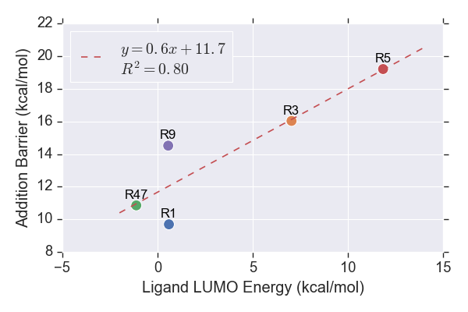

**Figure S4.** LUMO energies of the reactants.

### $β$-Carbon Charges

The HOMOs chosen for the calculation of $ω$ are roughly similar to Method I, except that the 3rd and 4th HOMOs are chosen for **R5** and **R9** instead of the 2nd and 3rd. The reason for the discrepancy in the energy hierarchy of the molecular orbitals is yet to be inspected.

It is interesting to note that the description power of the addition barriers by $ω$ was reduced to about 50% when the functional was changed to ωB97X-D. Despite the slightly poorer performance for most of the charge schemes, the Merz-Kollman and ChelpG charges calculated using Method G unexpectedly returned significantly higher $R^{2}$ values than calculations of Method I. It is possible that range-separated functionals are more suitable for computation of the 2 charge schemes. However, further investigations would be required for definitive conclusions to be drawn.

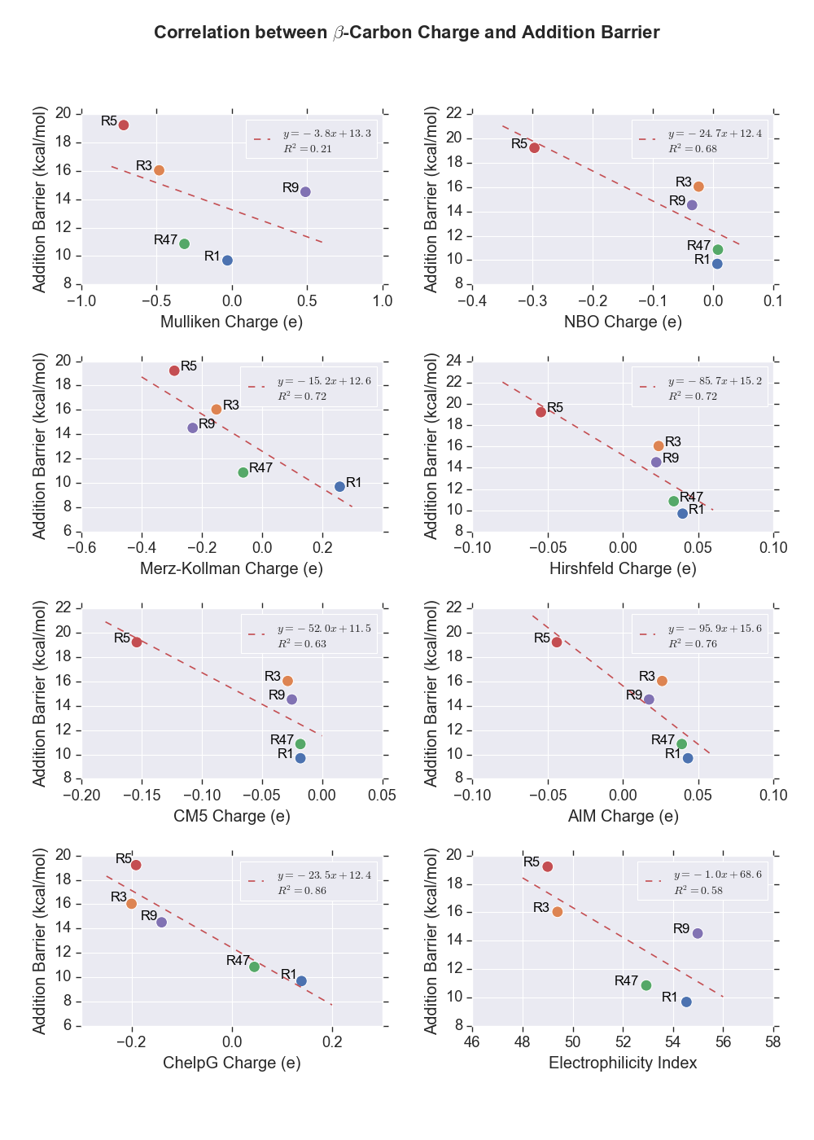

**Figure S5.** Partial charges of $β$-carbon and $ω$ of the Michael acceptors computed using Method G.

### Distortion/Interaction Analysis

The correlation trends showed by the components in the distortion/interaction analysis are similar to Combination I. The methylthiolate in **TS5** is still found to exhibit a greater distortion compared to the other TSs. The ligand distortion energy and activation energy returned high values of $R^{2}$ as seen from the analysis on results from Combination G. The interaction energy remains lacking in the predictive power of the calculated addition barriers. Furthermore, the previously seen hypothetical ideal linear fit through the rest of the data points excluding **R9** is now unclear.

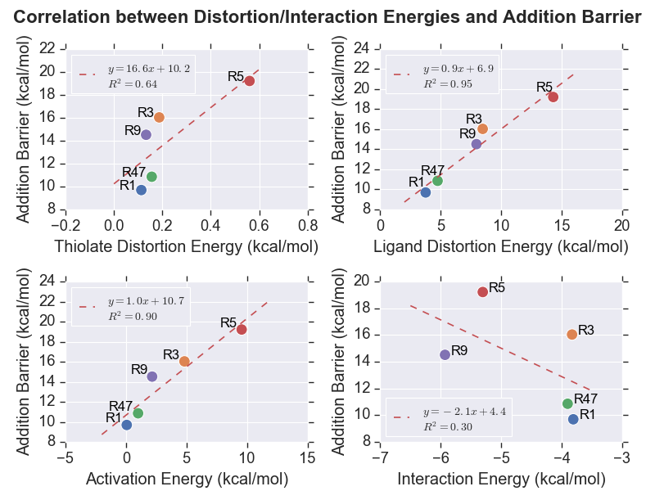

**Figure S6.** Plots showing the relationship between distortion energies of thiolate (upper left), and cyanoacrylamides (upper right), activation energies (lower left) and interaction energies (lower right) computed using Method G.

## Details of MD Parameters Used

### Preparation of GROMOS System

A threshold of 0.1% was specified for the *gch* program, which repositions H atoms for which the connecting bond deviates from the optimal distance by a percentage greater than the threshold.

The initial and maximum time steps for energy minimisations were set to 10 fs and 50 fs, respectively. All bond lengths were constrained using SHAKE algorithm with tolerance of 10-4.

The *@rotate* flag was specified to rotate the solute to direct the largest atom-atom distance between any 2 solute molecules along z-axis, and the largest atom-atom distance in the perpendicular plane points along y-axis prior to solvation. The default value of 2.3 Å was used for the minimum solvent to solute distance for the *sim_box* program. A rectangular PBC was used as the *pmemd.cuda* program could not handle non-rectangular PBC just yet.

A cutoff of 0.8 was specified for the Coulomb potential calculation for the *ion* program as it searches for the water molecule with highest potential to be replaced with Na+ ions. It should be noted that the replacement of water molecule with the ion could only be done one at a time as the subsequent ions would be inserted at exactly the same coordinates as the first ion. The reason for the phenomenon was not investigated due to time constraint.

A harmonic force constant of 2.5×104 Nm-1 was used to restrain the positions of specified solute atoms.

### Simulation of AMBER System

Apart from the first NVT simulation during equilibration phase and production phase, the initial velocity of all simulations were obtained from the previous runs. Otherwise, the velocity of each atom is sampled from Boltzmann distribution at the specified temperature as mentioned in the main text. The energy and coordinates were written out every 1000 and 2500 steps, respectively for simulations of less than 10 ns. The frequency of the storage of coordinates is halved for systems that run for 10 ns and above. The center of mass motion was removed every 1000 steps. All molecules were wrapped back into the box during the simulations to avoid the storage failure of large coordinates. No continuum correction was applied to energy and pressure in vdW interactions to prevent incompatibility with the Lennard-Jones parameters of the atoms in the systems built, which were parameterised without them. A cubic spline function was used as switching function of Coulomb forces. The skin distance for neighbour lists is set to 2 Å.

## Validation of Simulated Systems

The simulations of BTK were compared to the observables from the experiment in attempt to validate the MD simulations.

### RMSD of Protein Backbones from X-ray Crystal Structure

The deviations of the protein backbones from the experimentally measured structure are plotted as shown in Figure S7. Due to the protocol of the preparation of the simulation systems which involves multiple energy minimisations, the initial structures for the simulations are already deviated for about 1.5 Å from the X-ray crystal structure from which the systems were built. However, the fluctuations of the RMSD throughout the MD simulations are relatively small. The RMSDs are maintained at about 2.5 Å after equilibration for most of the runs. This indicates that the GROMOS parameters managed to reproduce the structural properties of the backbone of BTK to a reasonable extent.

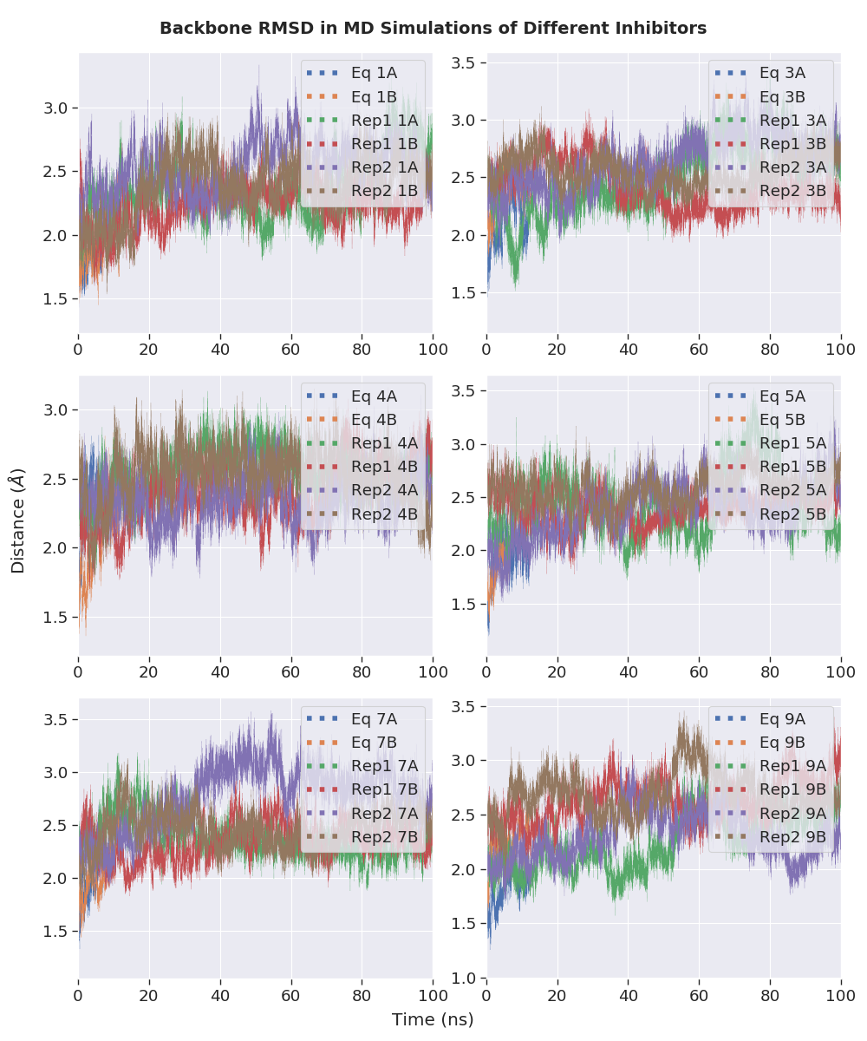

**Figure S7.** RMSD of BTK protein backbones from the X-ray crystal structure throughout the 100 ns MD simulations.

### Hydrogen Bond Analysis

The number of hydrogen bonds between the backbone residues of BTK during different MD simulations is plotted in Figure S8. It is found to fluctuate between 58 and 105 with a uniform peak of about 80 for all runs. This implies that no significant change in the conformation of BTK has happened during the simulations.

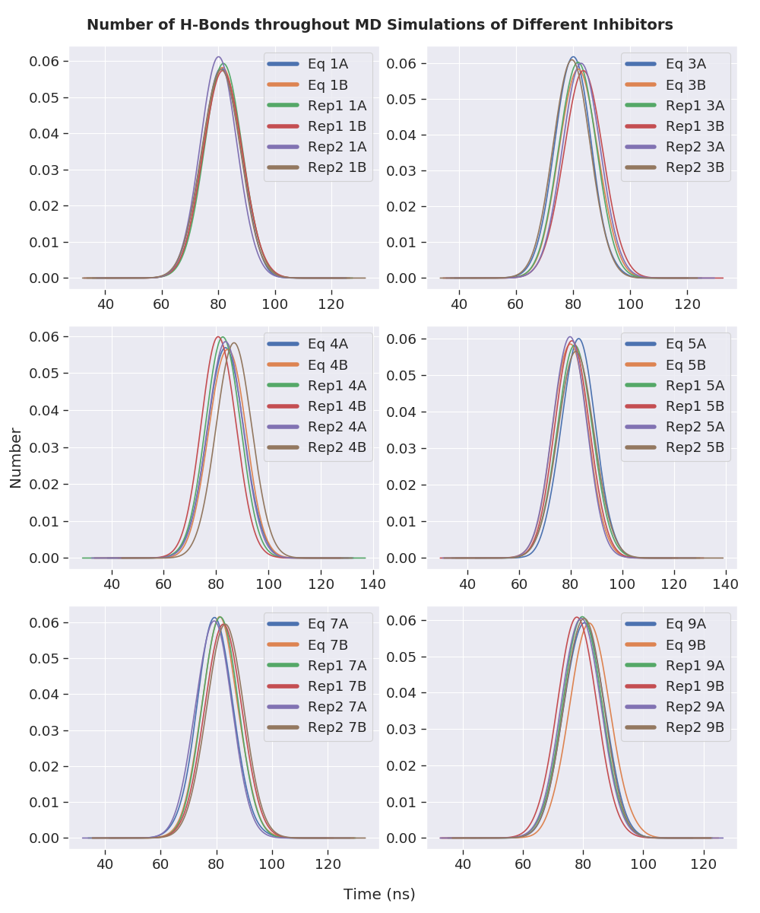

**Figure S8.** Distributions of the number of the hydrogen bonds between the backbone residues of BTK throughout the MD simulations of noncovalently bound BTK.

## Plotted Figures from Distance Analyses

In an effort to search for species with the potential of acting as base catalyst for the thiol additions/eliminations, the distances of the basic (histidine, lysine and arginine) and acidic (aspartate and glutamate) residues from the protons to be abstracted as functions of simulation time are plotted. Figure S9 and S10 showed the trajectories of the charged residues that have approached the protons of interest to within 10 Å at any point of the simulations.

### Potential Base for Thiol Eliminations

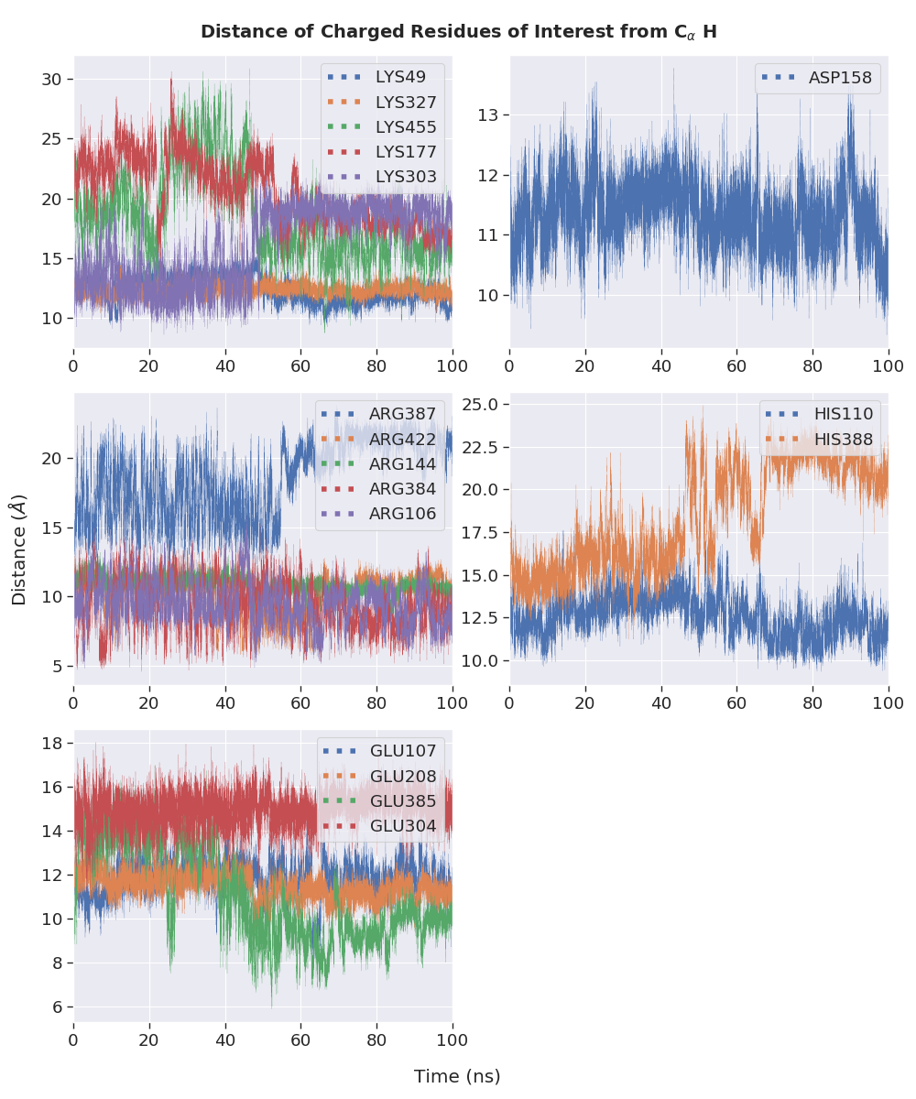

(a)

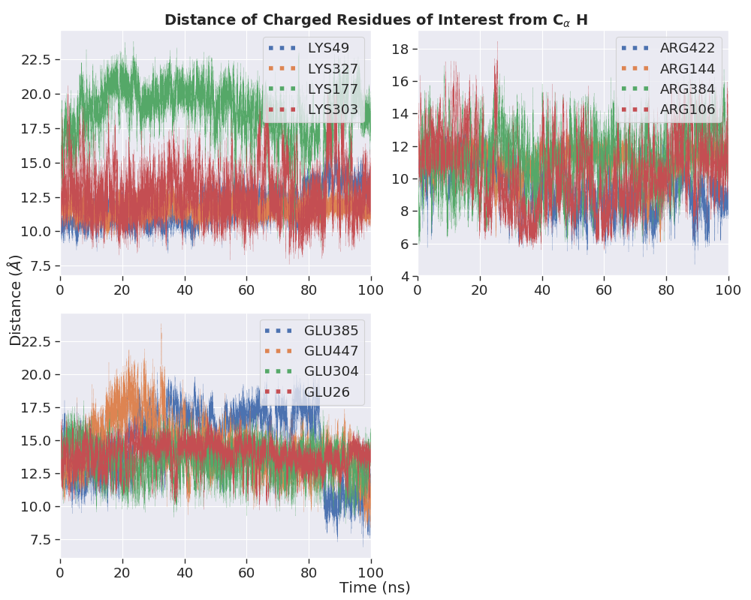

(b)

**Figure S9.** Distance between charged residues of interest and the C $α$ proton of the covalently bound (a) **1** and (b) **3**.

### Potential Base for Thiol Additions

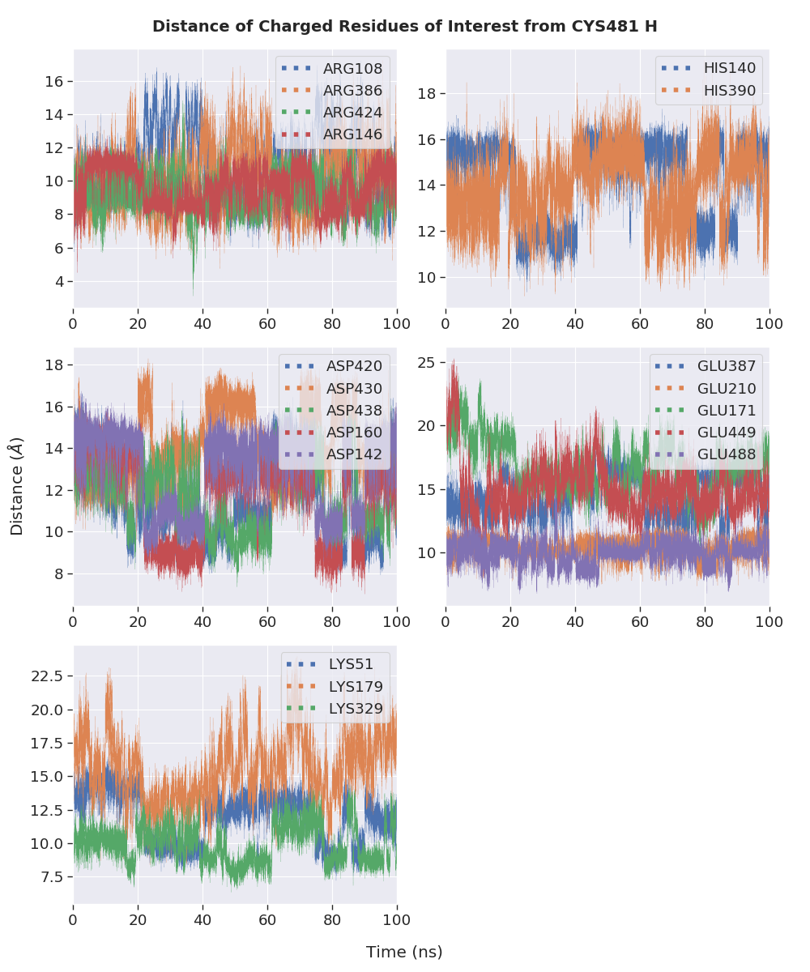

(a)

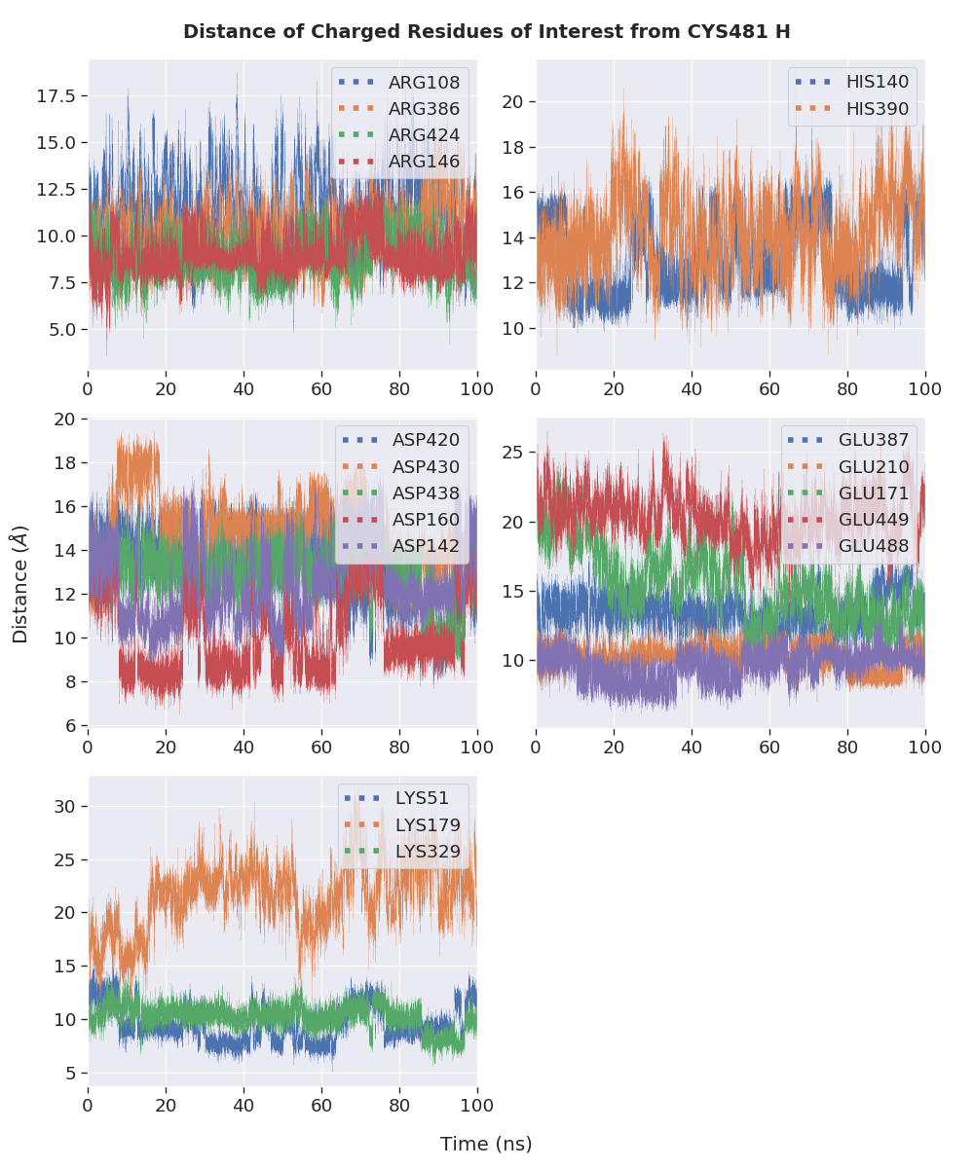

(b)

**Figure S10.** Distance between charged residues of interest and the thiol proton of the unreacted Cys481 of the noncovalently bound BTK containing systems (a) **1** and (b) **3**.

## Programming Scripts Written

All codes written by the author for the project were made publicly available on GitHub at <https://github.com/Jon-Ting/Honours>.

### Gaussian Job Generation and Submission

The Python scripts gaussian.py and settings.py in QM/run_gaussian directory work in conjunction with each other to generate Gaussian input files and submission files compatible with High-Performance Computing (HPC) clusters using PBS Pro workload management system (Raijin, Tinaroo, Awoonga, Argon). The Bash scripts *raijin_sub* and *rcc_sub* in Bash directory allows automatic submission of HPC jobs by looping through all directories.

### Management and Modification of Files and Directories

Functions in the Python file admin.py in QM/run_gaussian directory allow easy name-changing of multiple files or directories simultaneously, generation of new directories according to existing files, grouping them correspondingly, and splitting concatenated coordinates files containing multiple molecules into files containing exclusive data of individual molecule. The *rpname()* function in the *.bashrc* file ease the name modification of entries in terminals.

### Post-Calculation Correction, Tabulation, and Visualisation of QM Calculation Results

The *SCS_corr()* function in Gaussian.py was written to carry out spin-component-scaled (SCS) correction. The QM data of interest were extracted and tabulated in Excel sheets using tabulate.py in QM/run_gaussian directory. The *plot_fig.py* in QM/visual directory obtains the settings for each figure from *plot_config.py* and generates a graph consisting of one or more subplots for each properties analysed (reactant LUMO energies, $β$-carbon charges, and distortion-interaction analysis). The interconversions between $ΔG$ and $K$, and $ΔG_{rev}^{‡}$, $k_{off}$, $t_{1/2}$ and RT values were done using *calculation.py* in QM directory.

### Automated Analysis of MD Trajectories

Provided the template input files for the CPPTRAJ program, *post_amber_md()* function in the *.bashrc* file which utilises other functions (*mkvmdtop()* and *find_min_geom()*) was written in multiple programming languages (Bash, Sed and Awk) to automatically carry out the trajectory analysis, which includes stripping out solvent molecules and ions, setting the BTK dimers as the centre of the simulated box, reimaging the solute molecules, calculating RMSD relative to starting structure, generating VMD-compatible topology file, extracting the system properties (temperature, pressure, density, potential and kinetic energies), locating the geometry with minimum potential energy, calculating RMSD with respect to the most stable structure and generating an average structure.

### Preparation of MD Systems and Visualisation of MD Trajectory Analysis Results

The Python files *prep_mtb.py* and *sum.py* were written to ensure the parameters of the non-standard amino acids, especially the total charges of the corresponding systems are correct. The former provides functionality to map the overlapping atoms between 2 molecules, which could potentially be of use for other usage in the future. The plotting of the analysis of MD results was done using *base_id.py*, *SC_bond_dist.py*, *bb_rmsd.py*, *hbond_analysis.py*, and *lig_dihedral.py* in the MD directory.